**Tensorflow**

**Graf computational** = reprezentare sub forma de graf, al functiilor matematice.

**DNNs(Deep neural Networks)** = este un caz special de graf computational. Este format dintr-o serie de “fully connected layers”, adica outputul de la fiecare nod, din layer X, intra ca input, la toate nodurile din layer Y.

**Tensor** = este o matrice(sau un array)

**Logits** = In ML, este un vector de predictii raw(non-normalizate), pe care le genereaza clasificatorul, care apoi sunt redirectate catre o functie de normalizate. Daca modelul, rezolva o problema de clasificare multi-class, logits, defin inputs la o functie SoftMax. Functia SoftMax, genereaza apoi un vector(normalizat) de probabilitati cu o singura valoare pentru fiecare clasa posibila.

**One-Hot Encoding** = clasificare cu labeluri de (1 si 0).

**Cross-Entropy** = distanta dintre 2 vectori de probabilitate. Adica ai un vector de probabilitati si un vector de labeluri(sa zicem [1,0,0]).

**BroadCasting Tensorflow** = operation that allows arrays of different dimension to be added or multiplied with each othrer.

**SoftMax function** = preia scorurile tale, data de Wx+b si le transforma in probabilitati. (transforma ligits into probabilities)

-

**Hello World – Tensorflow**

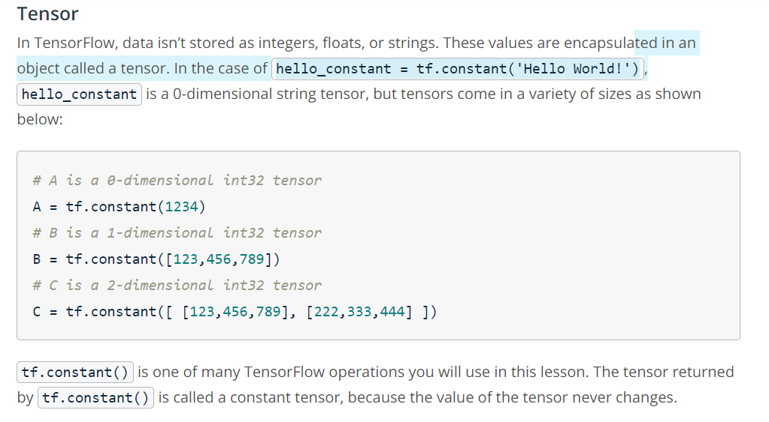

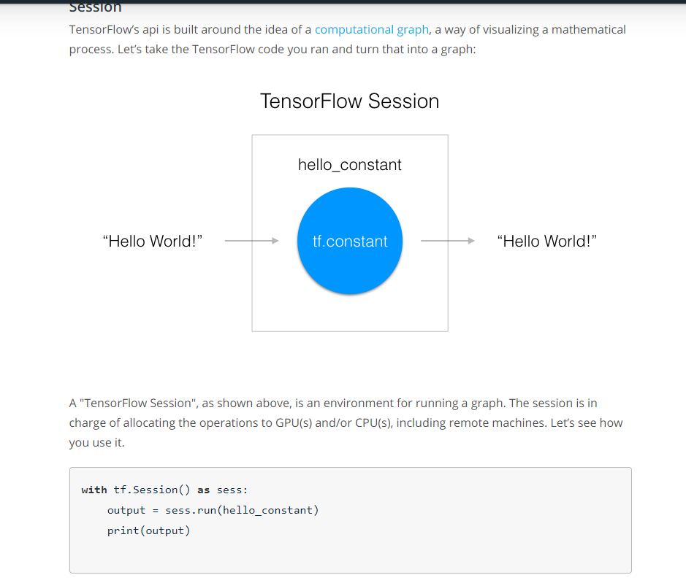

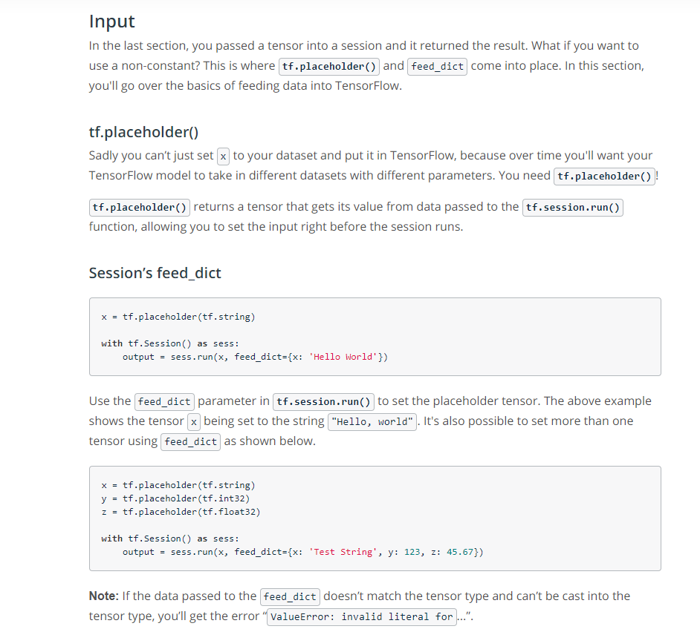

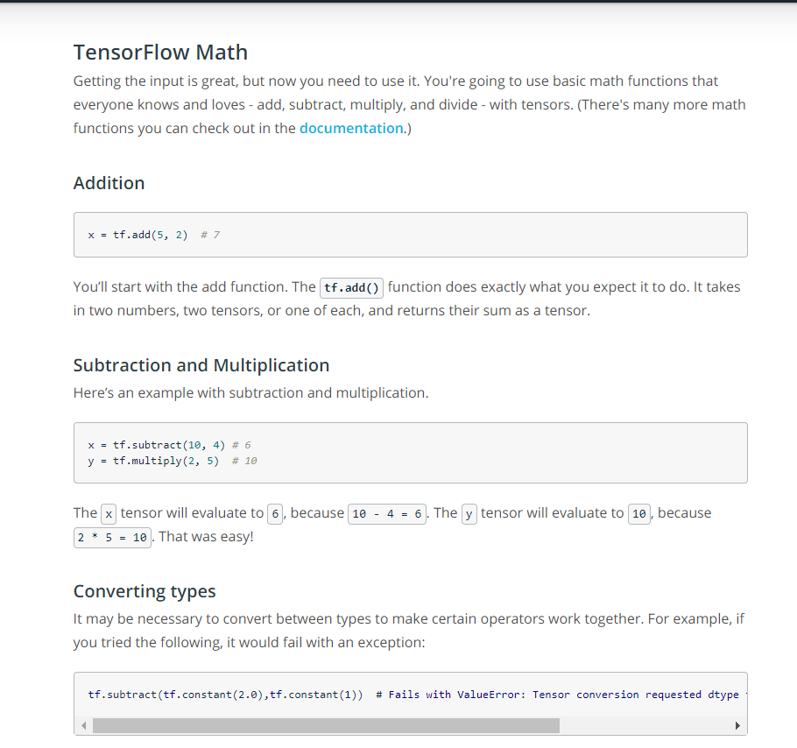

**Logistic Classifier**

<https://www.youtube.com/watch?v=WQsdr1EJgz8>

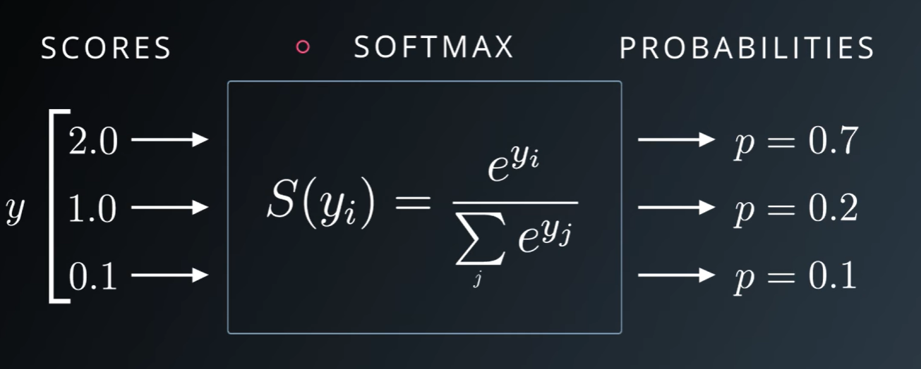

Logistic Classifier = Wx + b

* Se asociaza fiecarei imagini un score
* Apoi fiecare imagine are o probabilitate.
* Pentru a transforma un scor, intr-o probabilitate, se foloseste SOFTMAX function

**Tensorflow Liniar Function**

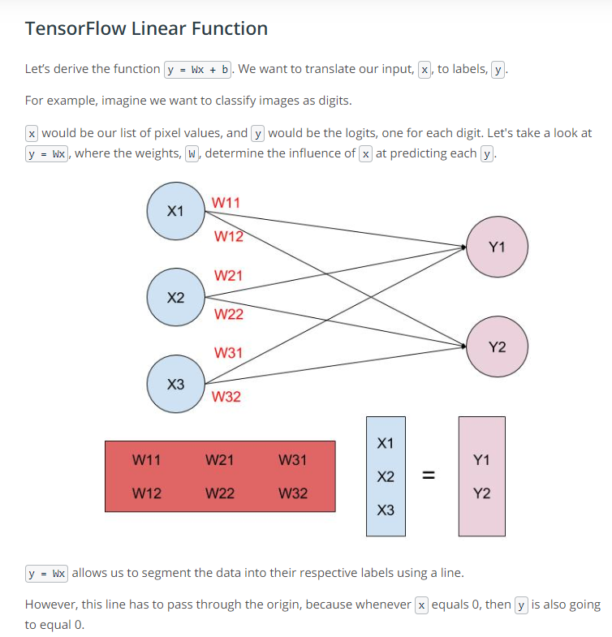

**Tine minte:** X este imaginea ta(o matrice), W = tot o matrice si tu vrei sa ii afli predictia (scorul)

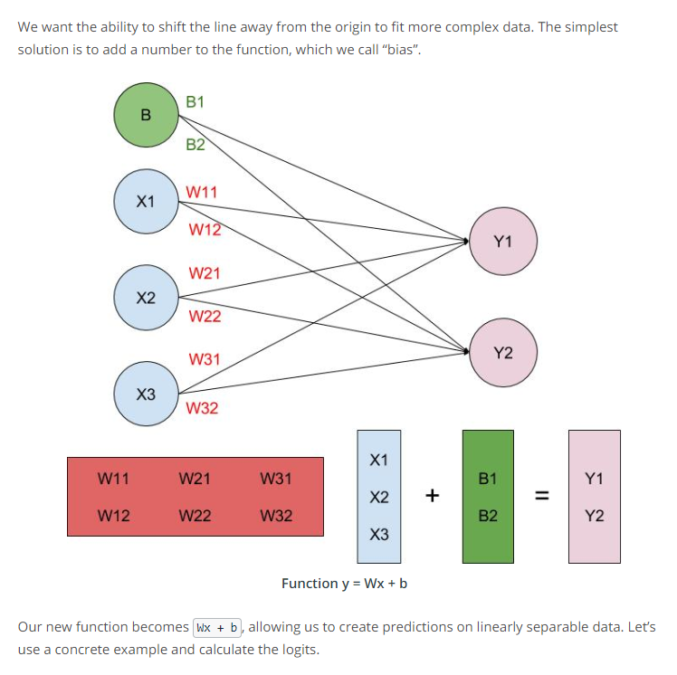

* Aici vrea sa iti spuna ca linia ta intersecteaza origina, si adunand cu un bias, biasul iti da unde se situeaza linia ta pe axa OY.

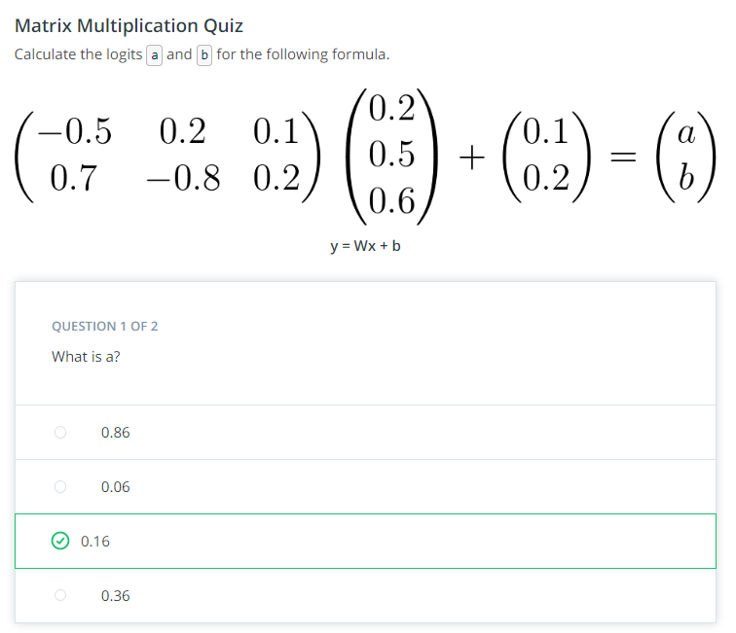

**Quiz Liniar Function**

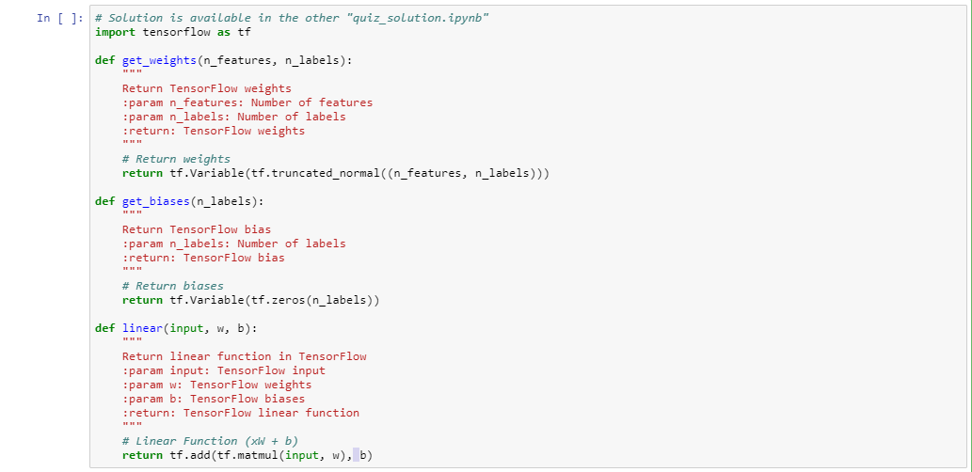

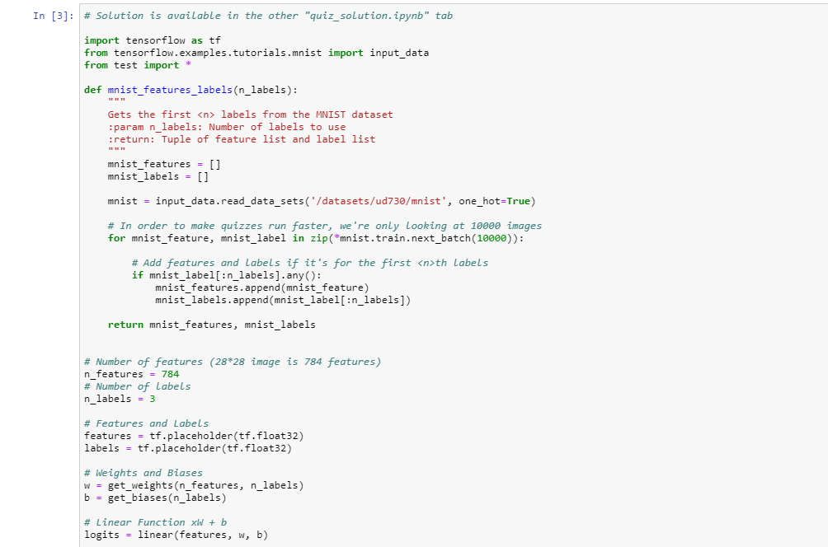

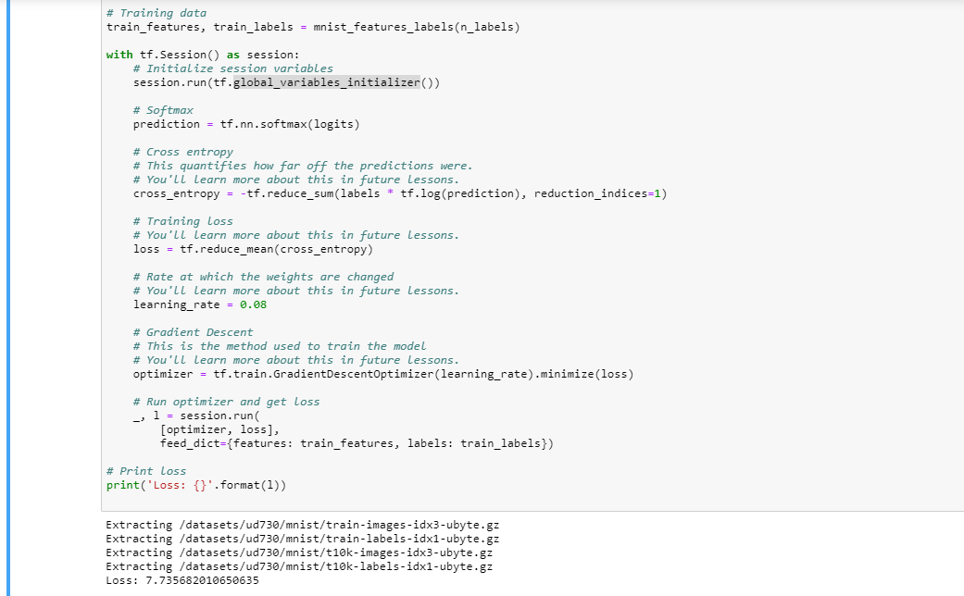

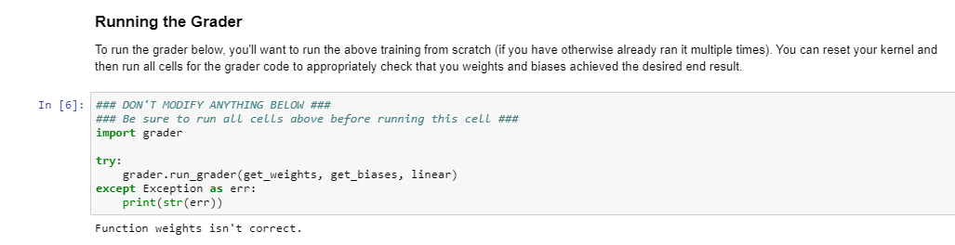

**Liniar Update**

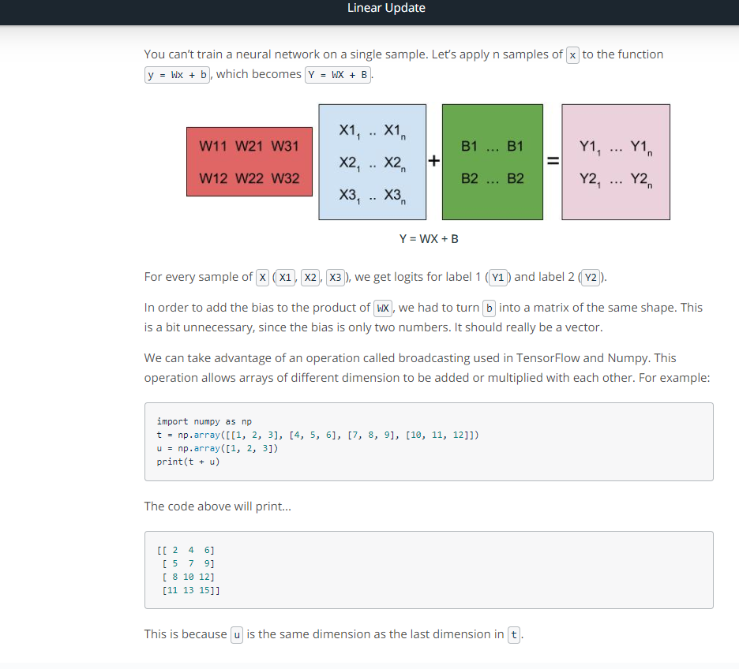

**Quiz SoftMax**

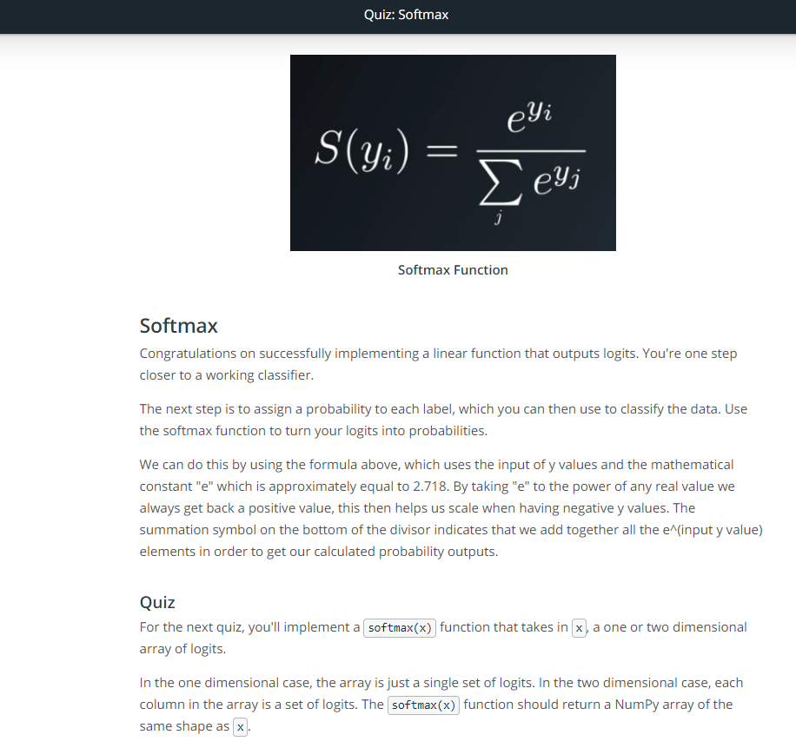

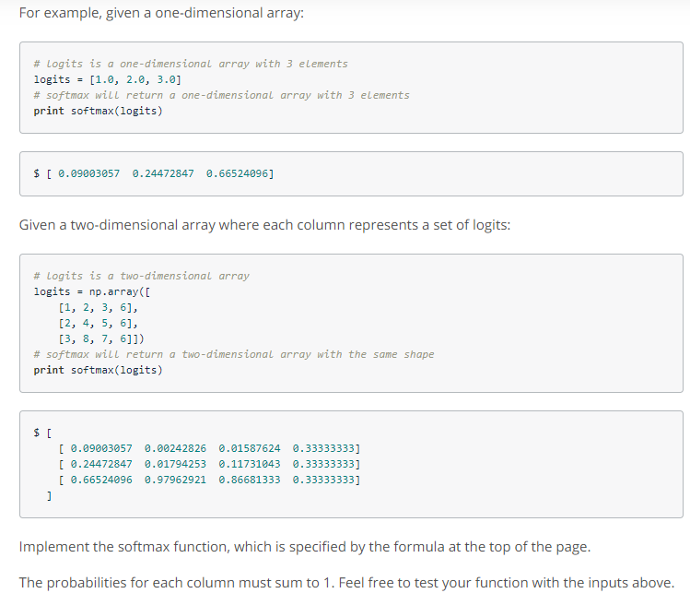

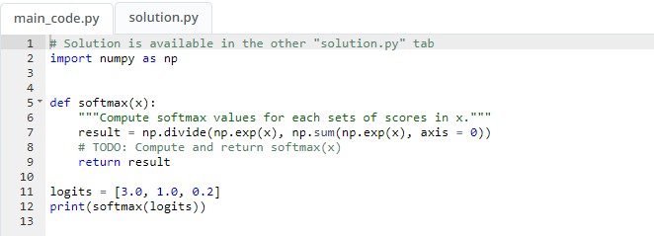

Tensorflow Softmax

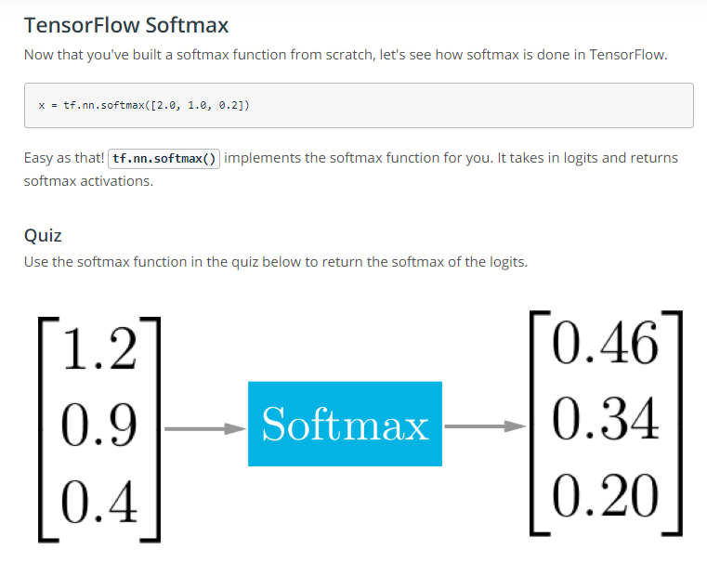

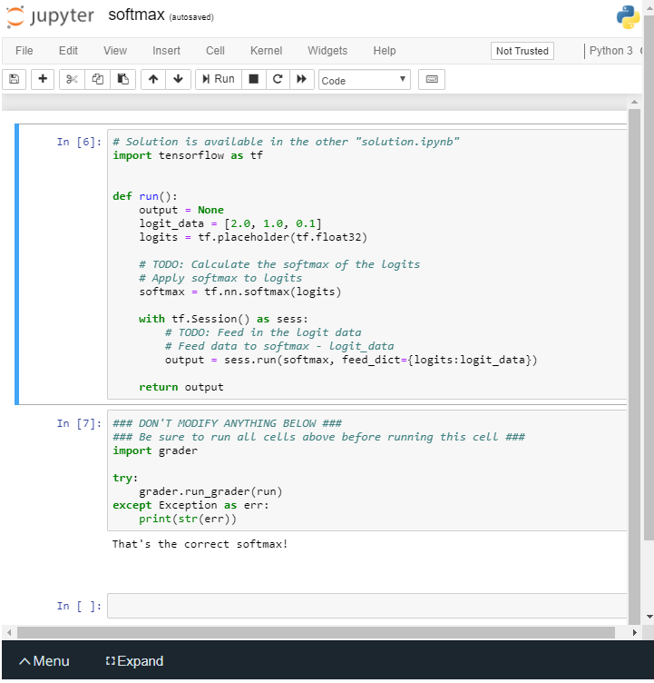

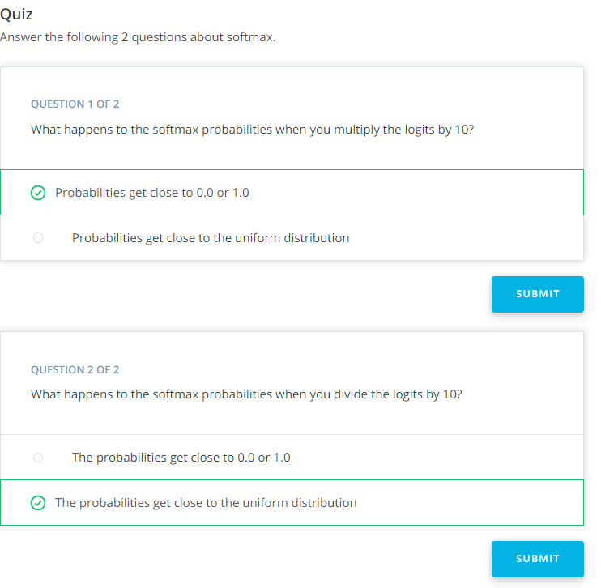

**One Hot-Encoding**

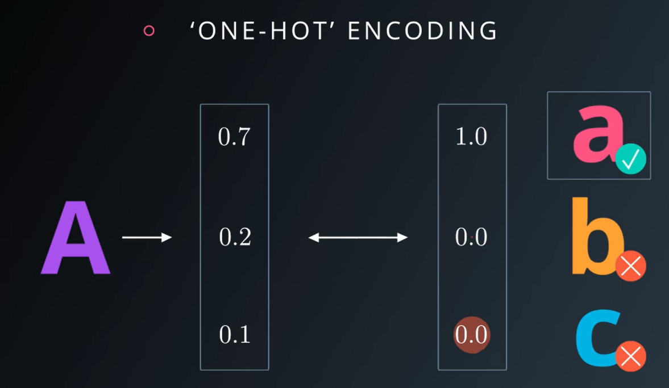

* Vezi acolo ca probabilitatile tale sunt labeluite cu 1(correct class) sau 0(altfel). Gen A, o sa fie in clasa a(mic).

Cross Entropy

Link: <https://www.youtube.com/watch?v=tRsSi_sqXjI>

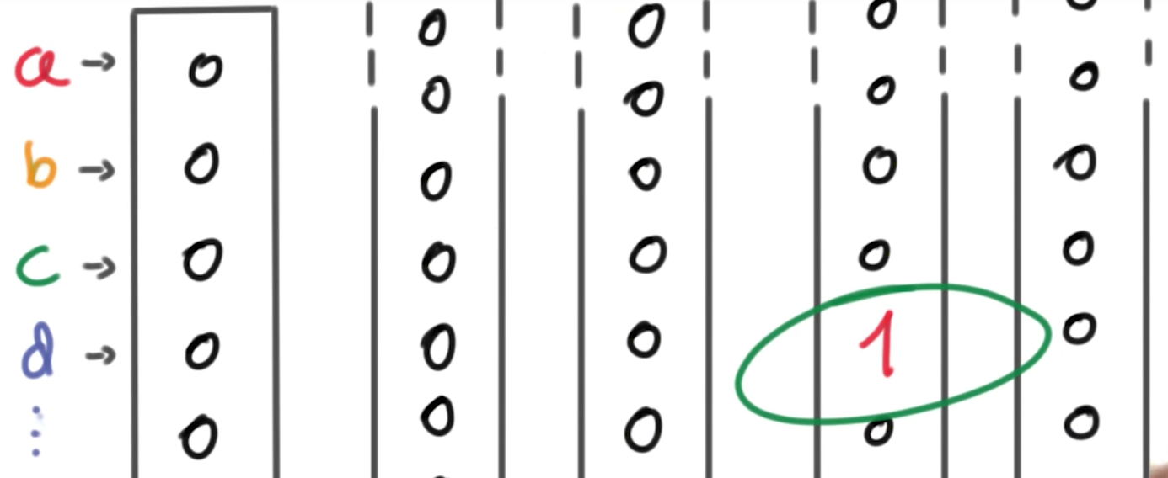

One-Hot Encoding este bun, dar daca avem foarte multe clase, imagineazati ca vectorul respective devine foarte foarte mare. (si este inefficient).

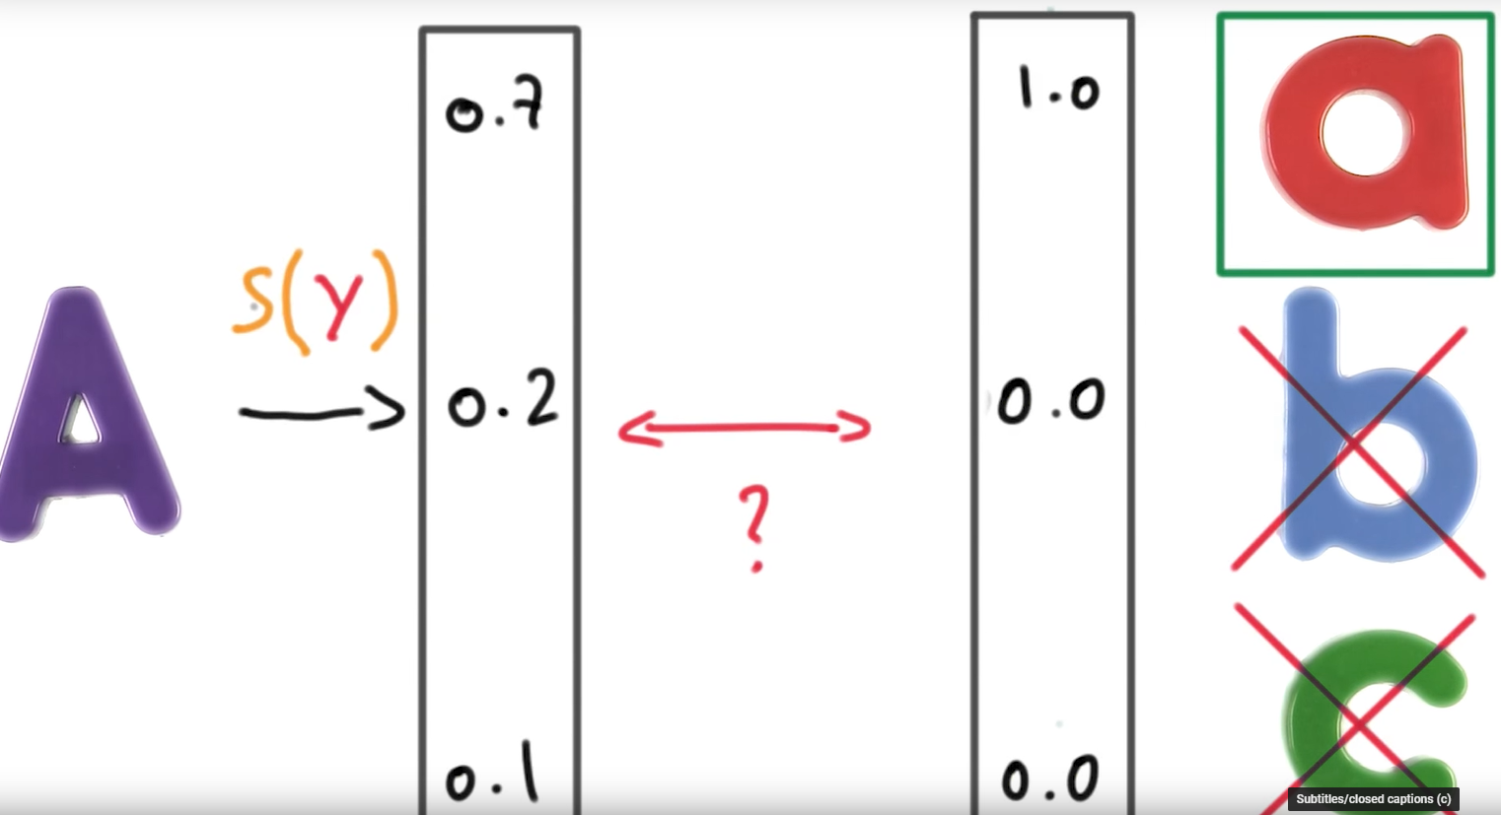

Deci practic noi vom compara 2 vectori, unulul care vine din clasificatorul nostru si contine probabilitatile claselor si un One-Hot encoded vector ce corespunde labe-urilor nostre.

In practica:

Cross Entropy:

Link: <https://www.youtube.com/watch?v=tRsSi_sqXjI>

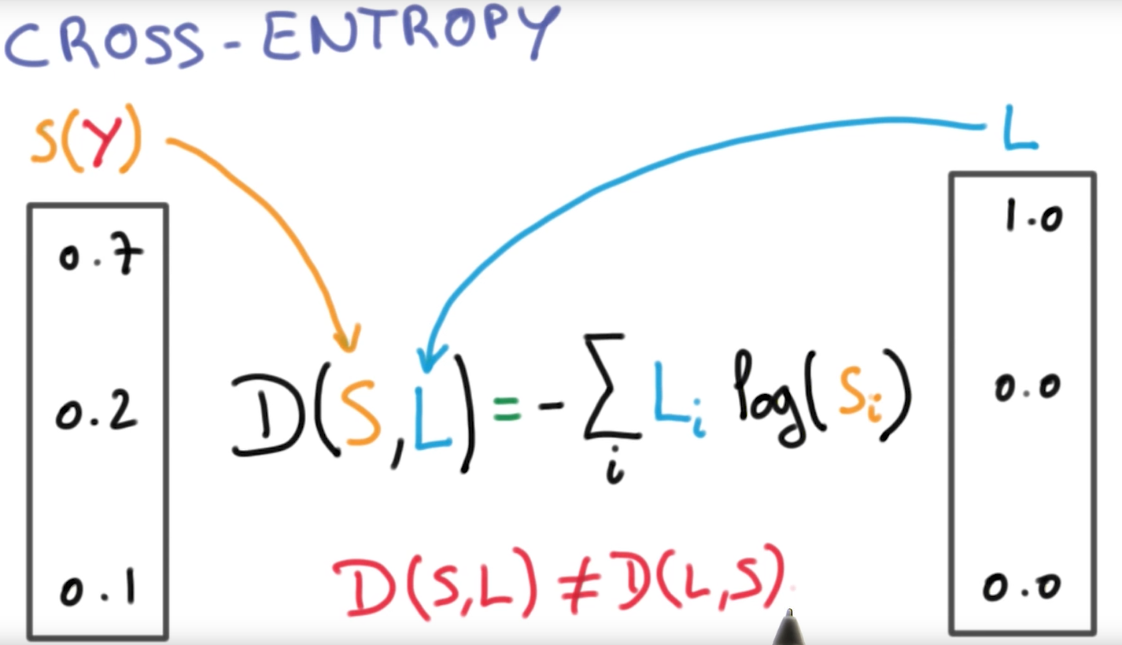

Cross Entropy = ne da distantele dintre cei doi vectori S si L.

Unde D = distanta.

**! Cross Entropy nu este simetrica. Deci trb sa te asiguri ca labeurile si distributiile tale, sunt plasate bine**

! trebuie sa te asiguri ca logaritmul tau nu va lua o valoare = 0. Dar din fericire, pt distributia realiata, softmax ne va garanta ca avem ceva acolo putin peste > 0.

Recap:

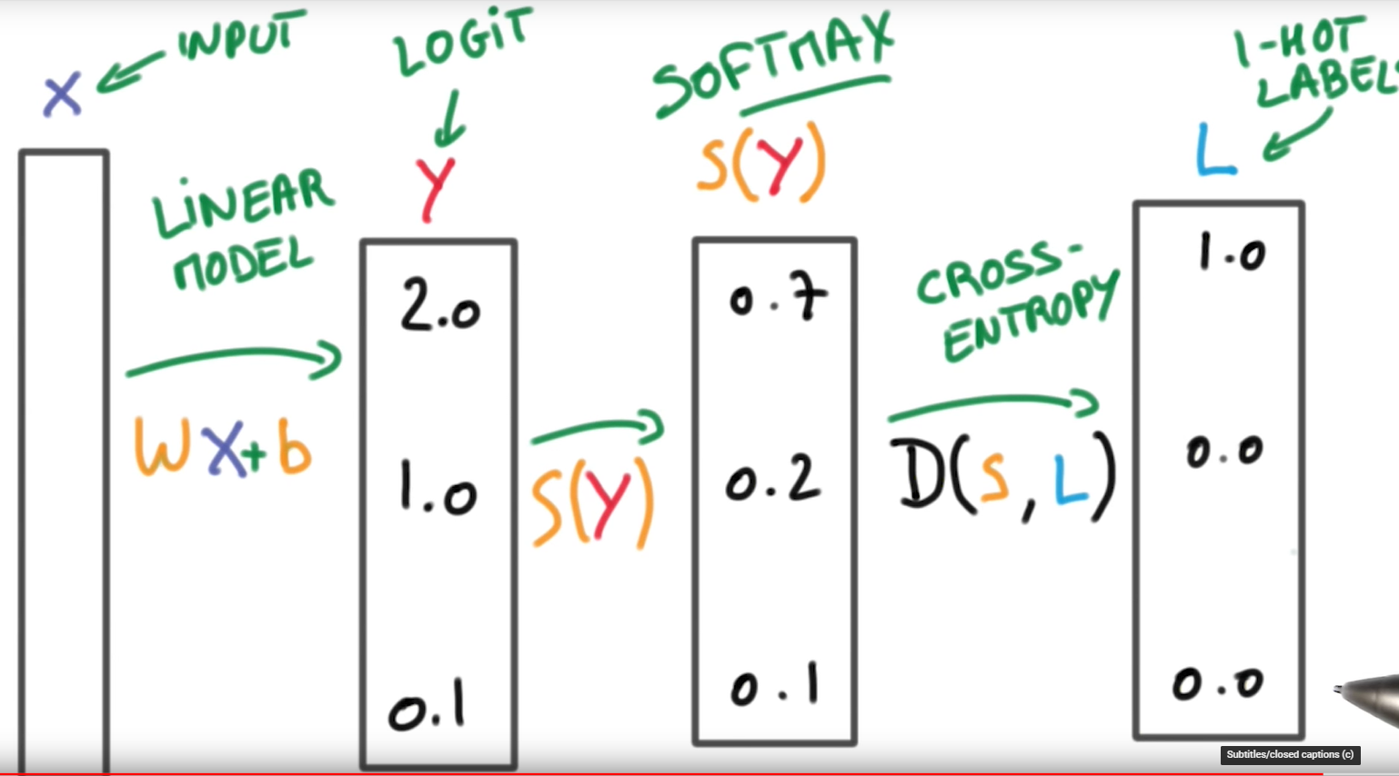

* Avem un imput ce va fii converit in logits prin Liniar Modelul nostru.(inmultire de matrice + bias)
* Apoi: We are going to feed the logits, “which are scores” into a **softmax** to turn them into probabilities.
* Then, we are going to compare those probabilities to the **one-hot encoded** labels, using the Cross-Entropy function.

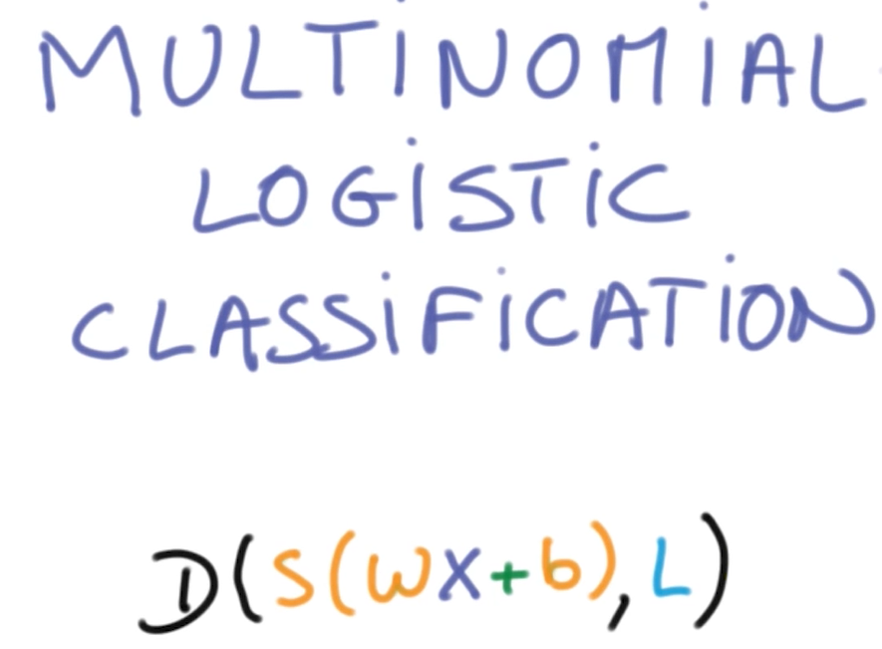

The entire Setting is often called **Multinomial Logistic Classification**.

**Minimizing Cross Entropy**

Link: <https://www.youtube.com/watch?v=YrDMXFhvh9E>

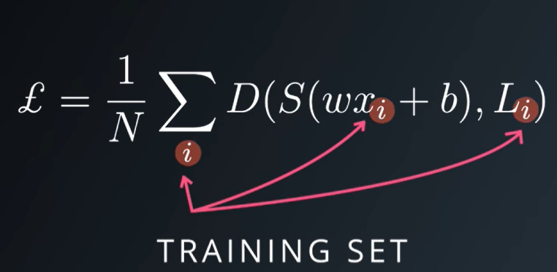

* Now we have all we need for the puzzle. The question of course, is how we’re going to find those weights **w** and **b**(bias)**, that** will get our classifier to do what we want it to do.
* That is: having a low distance for the correct class, but high disntace for the incorrect Class. => adica Cross Entropy-ul tau daca este mic (de preferat intre 0-1), atunci avem clasa corecta.
* **Ce putem sa facem**: is to measure that distance averaged over the entire training set, for all the inputs and all the labels that you have available.
* Asta se numeste: **Training Loss:**

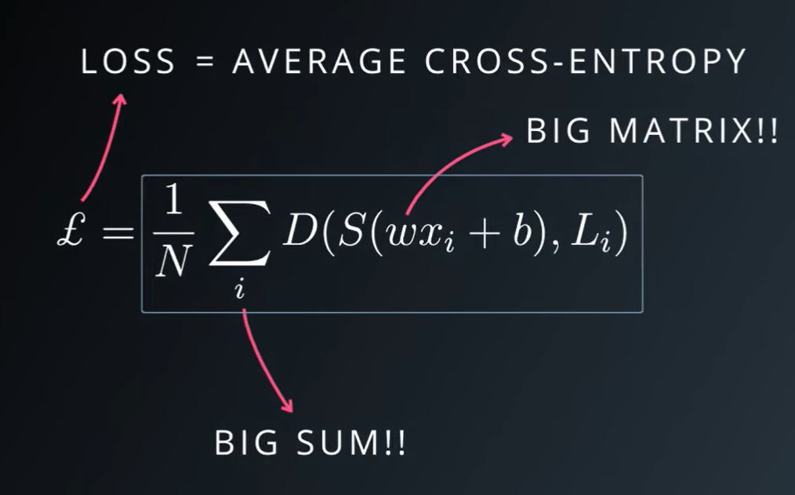

* Acest lost, este media cross-entropy over your entire training set.
* Every example in your training set, gets multiplied by this one big matrix W, and then, they get all added up in one BIG SUM.
* We want all the distances to be small, which would mean, we’re doing a good job at classifying every example in the trainig data. So we want the loss to be small.
* The loss is a function of the **weights** and the **biases**, so we are simply going to try and minimize that function.

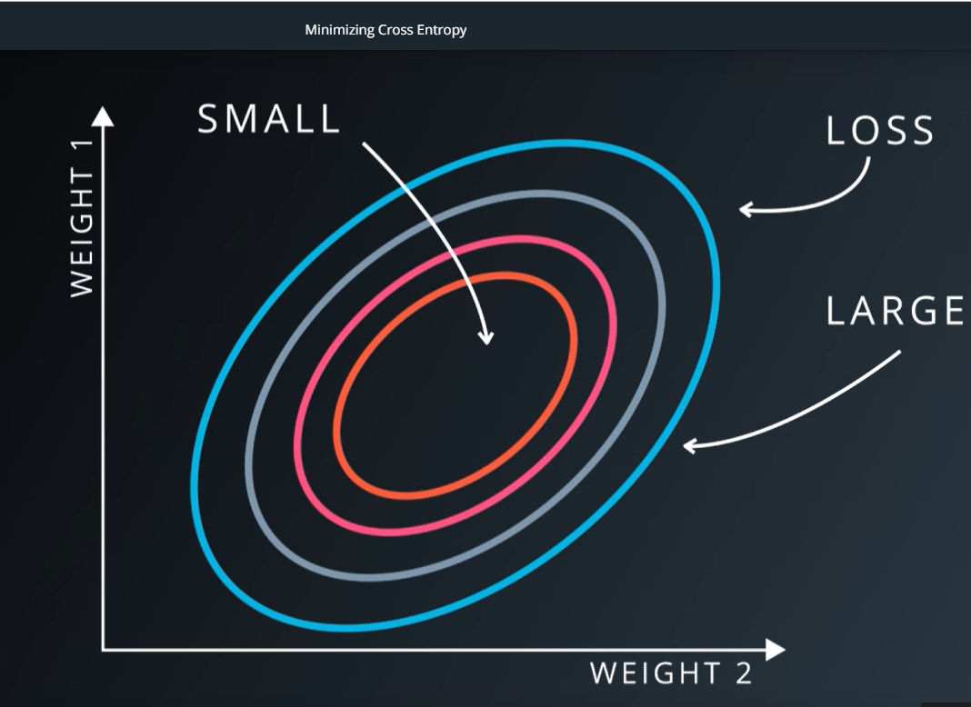

Imagine that the loss is a function of two weights (weight 1 and 2). It’s going to be a function which will be large in some areas, and small in others.

We’re going to try to find the weights which cause this loss to be the **smallest**.

We’ve just turned the machine learning problem into one numerical optimization.

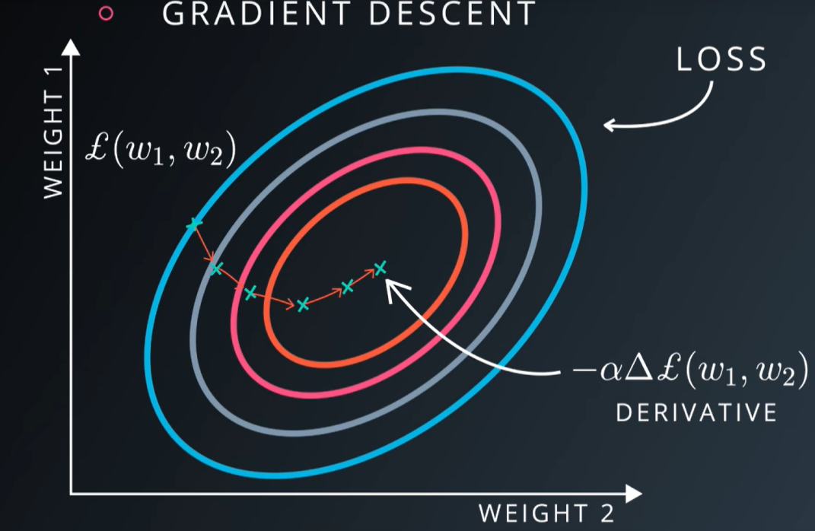

And there’s a lots of ways to solve a numerical optimization problem. The simplets way is one you’ve probably encountered before, **Gradient Descent** => take the derivative of your loss, with respect to your parameters, and follow that derivative by taking a step backwards and repeat until you get to the bottom.

Gradient descent is relatively simple, especially when you have powerful numerical tools that compute the derivatives for you.

Until now, this was the derivative for 2 parameters. But for a typical problem, it could be a function of thousands millions, or even billions of parameters.

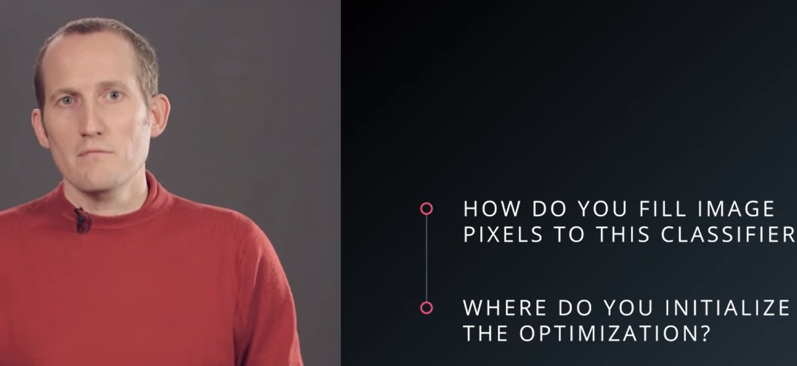

* Pana acum, sa consideram acest optimizer ca un Black Box. In continuare trb sa ne lamurim cu urmatoarele probleme:
* 1. Cum introducem pixeli unei imagini in clasificatorul nostrum.

2. Unde initializam noi acest optimizer?

**Normalized Inputs and Initial Weights**

Link: <https://www.youtube.com/watch?v=WaHQ9-UXIIg>

* Vrem ca lossul nostru, sa nu fie prea mare sau prea mic.

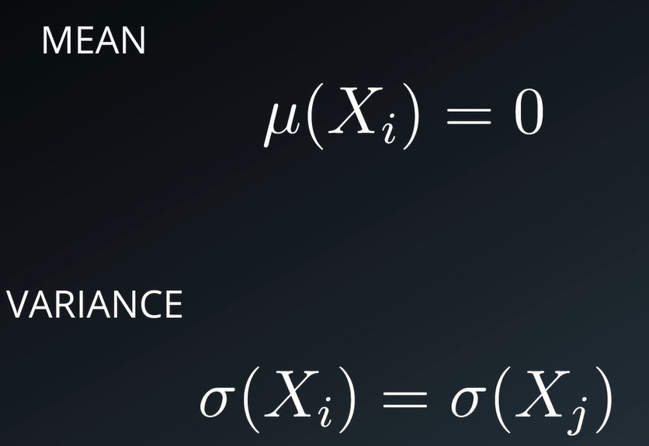

* As a guide principle, we always whant our variable to have whenever possible:
* Mean = 0
* And equal Variance.

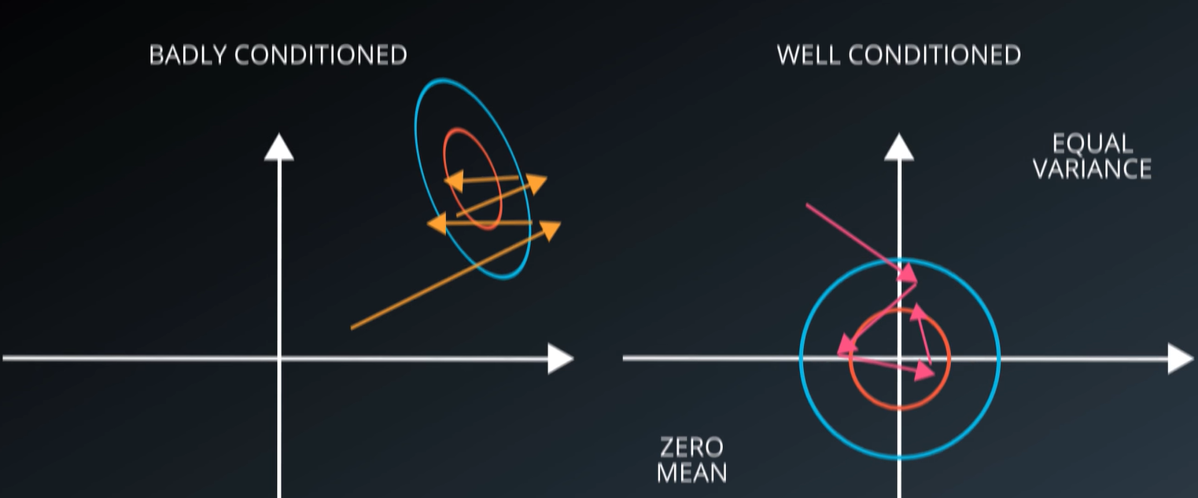

**Badly Conditioned** = atunci cand algoritmul nostrum, trb sa caute foarte mult pt a gasi o solutie buna.

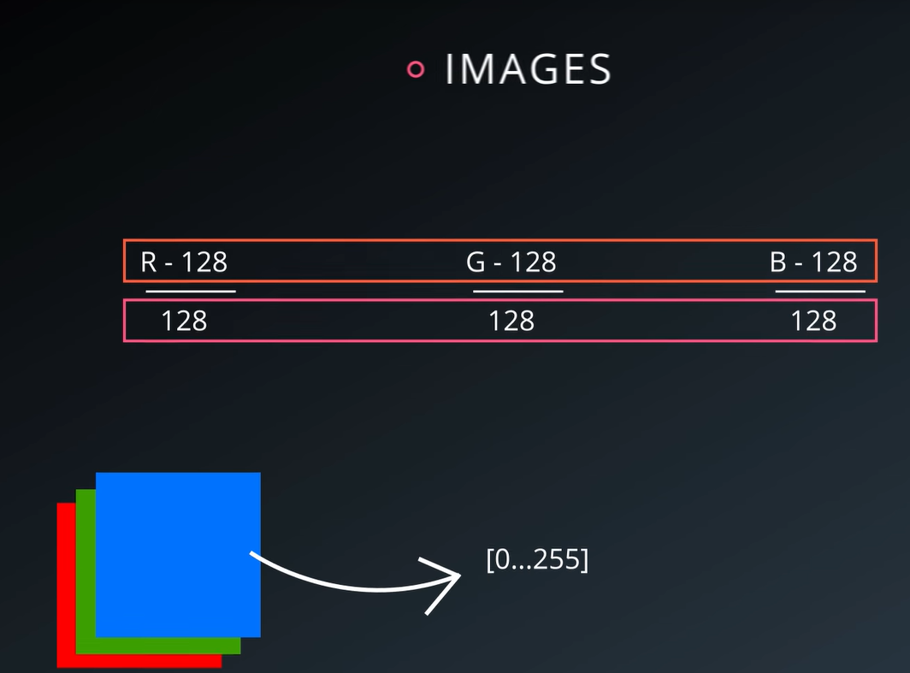

For images, is simple. You will take the pixels values of your images, typical between [0..255]. And substract 128 and divide by 128.

It will not change the content of your image, but it makes it much easier for optimization to proceed numerically.

We also want our weights and biases to be initialized at a **good enough** starting point for the gradient descent to proceed.

There are a lots of fancy schemes to find a good initialization values, but for now let’s focus on a simple general method.

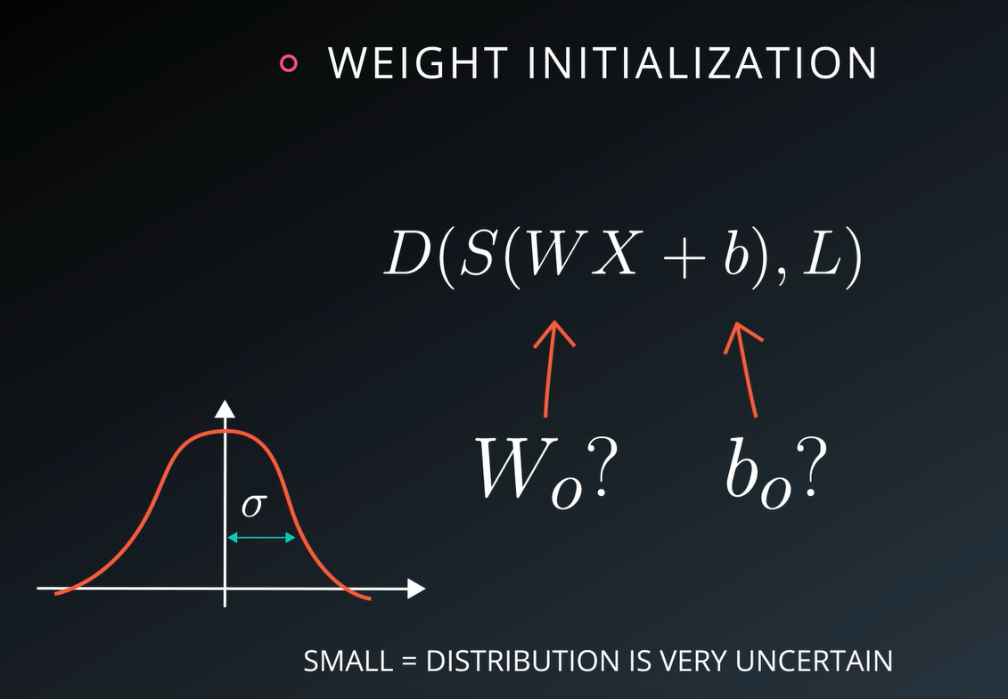

1. Draw the weights randomly from a Gaussian distribution would mean zero and standard deviation sigma.
2. **Sigma value** = determines the order of magnitude of your outputs at the initial point of your optimization.
3. Because of the softmax on top of it, the order of magnitude also determines, the peakiness of your initial probability distribution
4. **Large Sigma** => will mean that your distribution will have large peaks. It’s going to be very opinionated
5. **Small Sigma** => means that your distribution is very uncertain about things. It’s usually **better to begin with uncertain distribution**, and let the optimization become more confident as the training progress.

TO remember: always use a small sigma to begin

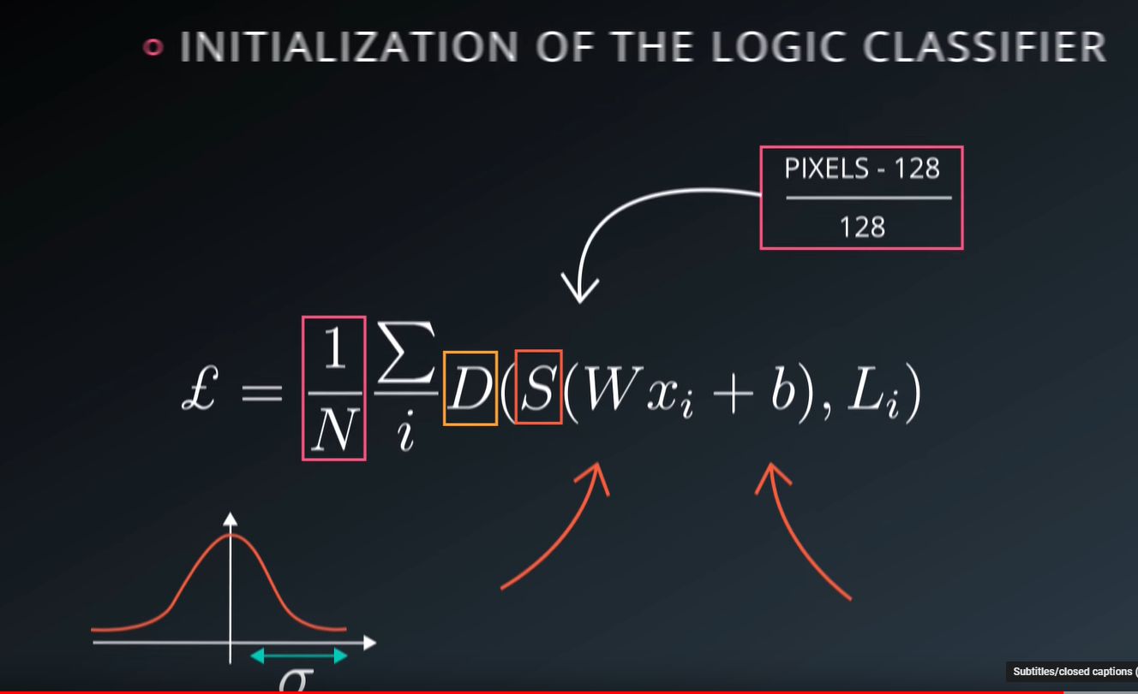

OK, so now we have everything we need to actually train this classifier.

* We got our training data, which is normalized to have zero mean and unit variance.
* We multiply it by a large matrix, which is initialized with random weights,
* We apply the softmax then the Cross Entropy loss and we calculate the average of this loss, over the entire training data.

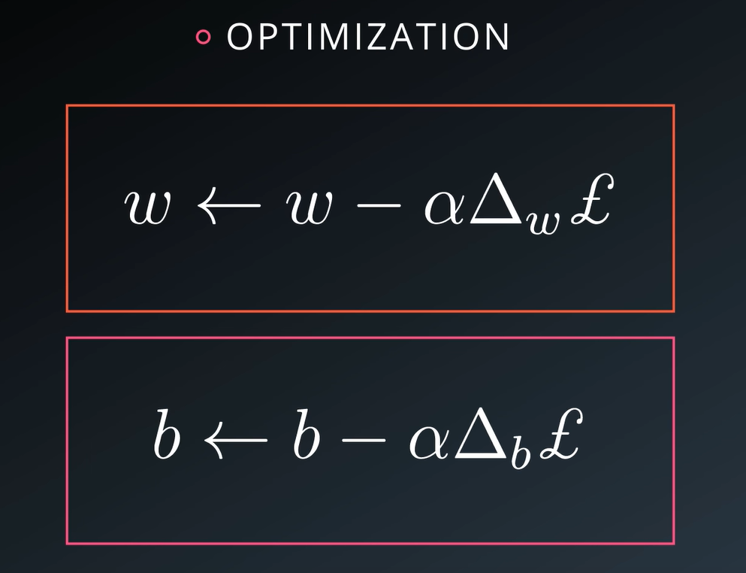

Now our magical optimization package computes:

1. The derivative of this loss with respect to the weights in to the biases,
2. And take’s a step back in the direction opposite to that derivative

**Measuring Performance**

Link: <https://www.youtube.com/watch?v=byP0DJImOSk>

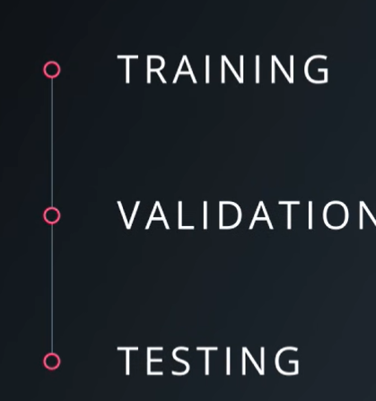

One you know how to measure your performance of your problem, you’ve already solved half of it.

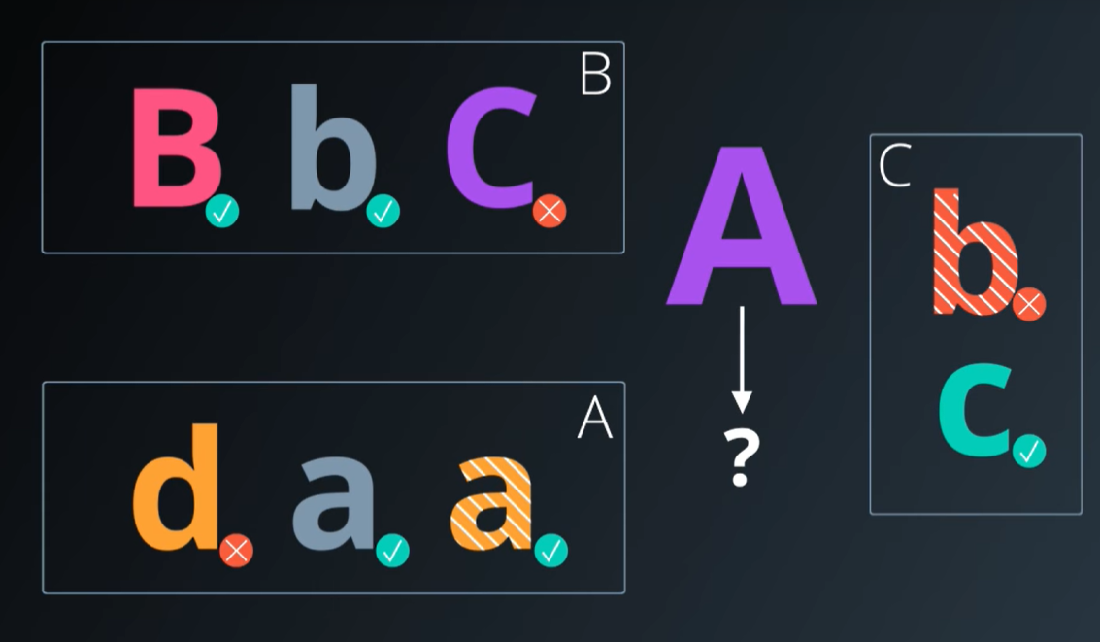

De ce este bine sa masuram?

Pai de exemplu sa zicem ca am facut clasificatorul si mie imi da destul de bine toate valorile.

Dar daca venim cu alta imagine si el nu stie in ce categorie sa o clasifice?

Deci ce facem? Imagineazati ca vom construi un clasificator, care pur si simplu compara noua mea imagine cu oricare alta imagine ce deja am evaluate din training setu-ul meu si doar returneaza label-ul.

In acest fel, putem avea 100% accuracy pe training set. Dar in momentul cand vede o noua imagine, se pierde, nu stie ce sa faca.

**Problema**: este ca, clasificatorul tau a memorat training set-ul si da fail cand vrea sa generalizeze la noi exemple.

Ce trb sa faci tu: este s ail ajuti sa generalizeze atunci cand primeste noi date.

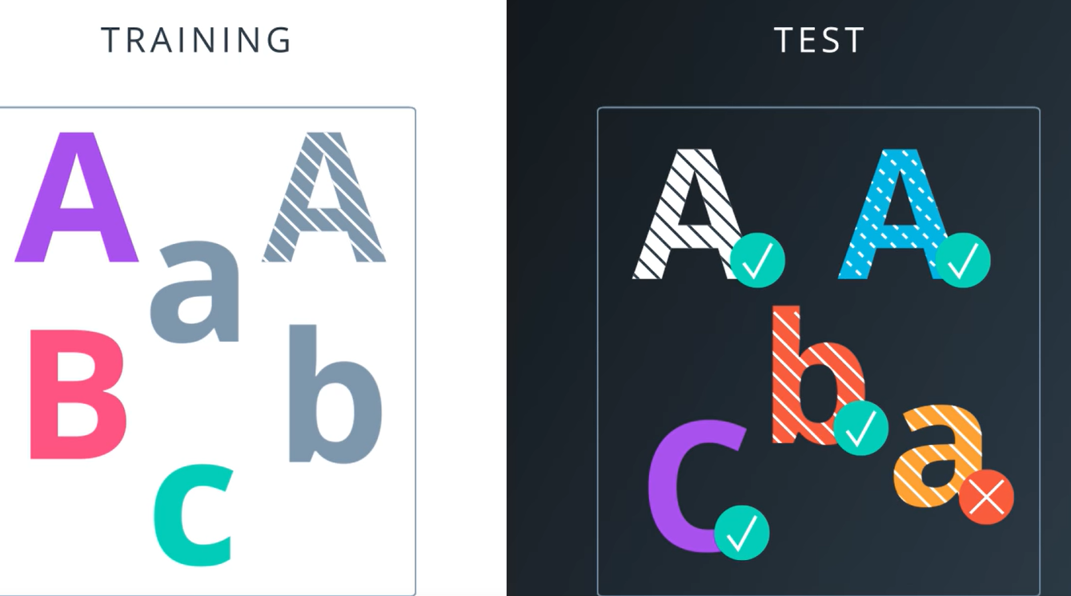

**So, How do we measure generalization instead of measuring how well the classifier memorized the data?**

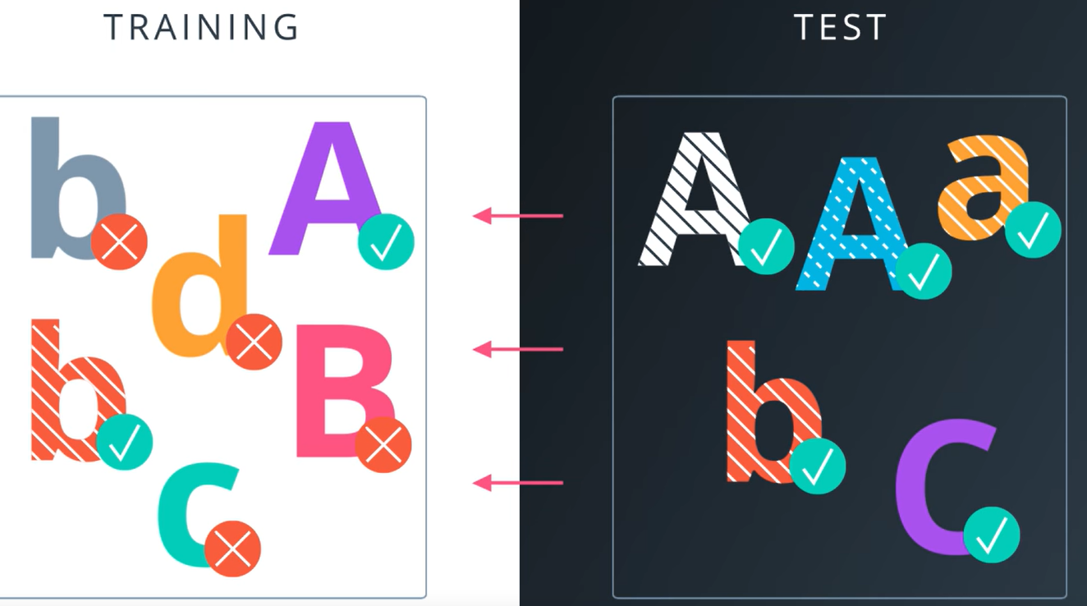

**Metoda cea mai simpla:** is to take a small subset of the training set, not use it in training, and measure the error on that test data. Problem solved, now your classifier cannot cheat, because it never sees the test data, so it **can’t** memorize it.

But there is still a problem. Because training a classifier is usually a process of trial and error.

You try a classifier, you measure it’s performance and then you try another one and you measure it again. And another, and another , you tweak the model, you explore the parameters, and finaly you think is the perfect classifier. And then after, all this care you’ve taken to separate your test data from your training data and only measuring your performance on the test data, now you deploy your system in a real production environment. And you get mode data, and you score your performance on that new data, and **it doesn’t do nearly as well**.

**What can possibly have happened?**

R: what happened is that your classifier has seen your test data, **indirectly throw your own eyes.**

**Every time you made a decision about which classifier to use, which parameter to tune, you actually give information to your classifier about the test set.**

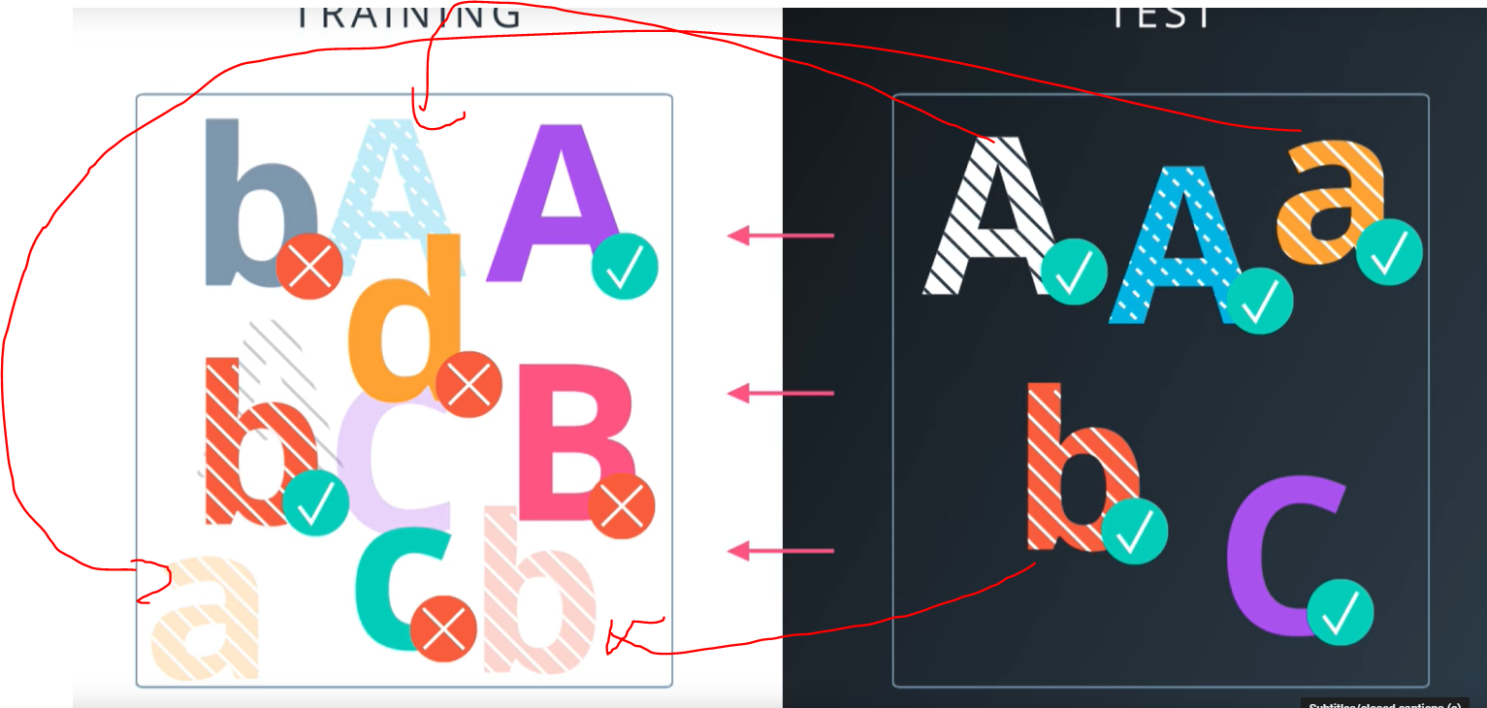

So over time, when you run many experiments, your test data bleeds into your training data.

**So what can you do?**

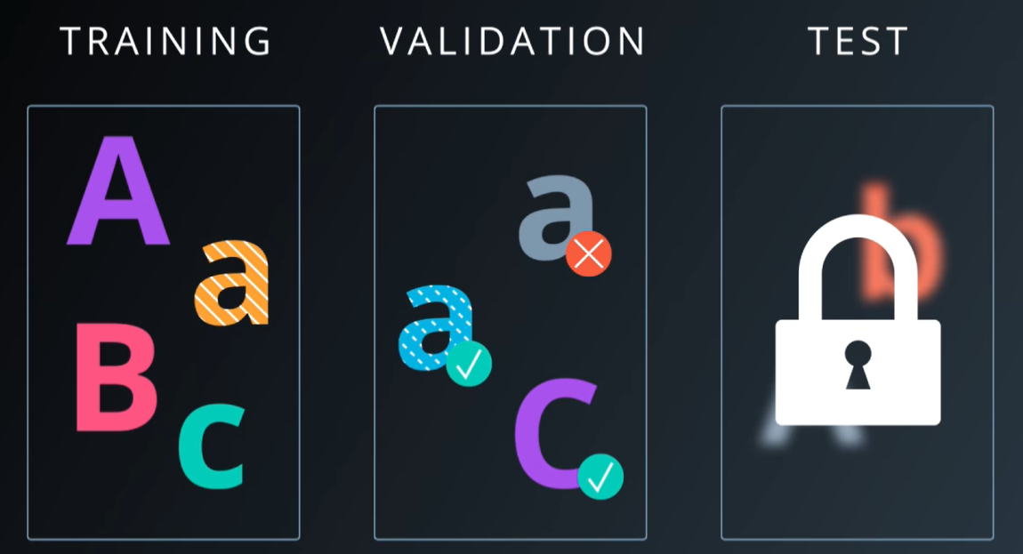

1. Take another chunk of your training set and hide it under a rock. Never look at it, until you have made your final decision.
2. You can use your validation set to measure your actual error, and maybe the validation set will bleed into the training sets. But that is okey, because you’ll always have this test set, that you can rely on to actually measure your real performance.

**Transition: Overfitting-> Dataset Size**

Link: <https://www.youtube.com/watch?v=iC2QOiavbrw>

**! The bigger your test set, the less noisy the accuracy measurement will be**

Link Quiz: <https://www.youtube.com/watch?v=-2XvoG6WD9k>

Validation set size link: <https://www.youtube.com/watch?v=cgoB-MJObmw>

**Optimizing a Logistic Classifier**

Link: <https://www.youtube.com/watch?v=U_7nO1dm2tY>

* Zice ca desi folosesti Gradient Descent for Optimizing, **NU SCALEAZA FOARTE BINE**

**Stochastic Gradient Descent**

Link: <https://www.youtube.com/watch?v=U9iEGUd9kJ0>

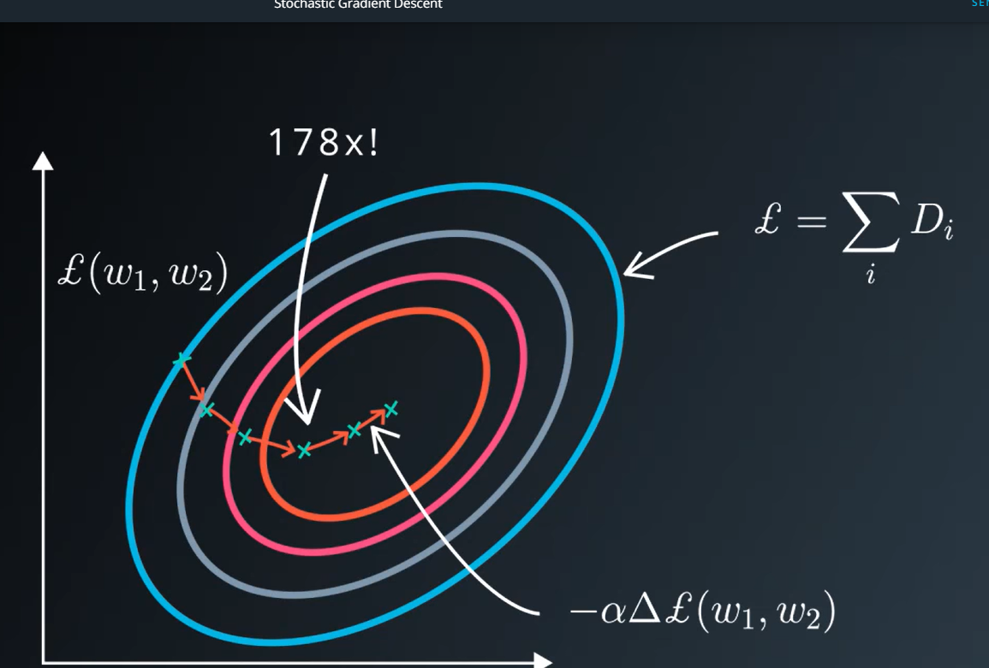

Ce trb sa stii:

* Cand calculezi Losul tau, cand faci gradient descent pe el, dureaza de 3x mai mult.

Dupa cate am vazut, acel Loss function, depinde de fiecare element din setul nostru de **training**.

Gradient Descent este iterativ si asta necesita sa mergi prin datele tale de sute chiar mii de ori.

**Deci ce facem?**

In loc sa calculam loss-ul, vom calcula o **estimare a lui, una foarte proasta, teribil de proasta.**

Estimarea o realizam, prin a calcula media loss-ului pentru fiecare fractiune (bucatica) luata random de trainingul nostrum de date.

Luam random, pt ca este foarte important. Daca nu este indeajuns de random, cand preiei datele, nu va functiona.

Deci,

Vom lua o mica bucatica din training data, **calculam** lossul cu aceasta bucatica, calculam apoi derivata cu acea bucatica **si vom predinde ca acea derivative este directia buna pentru a folosi gradient descent.**

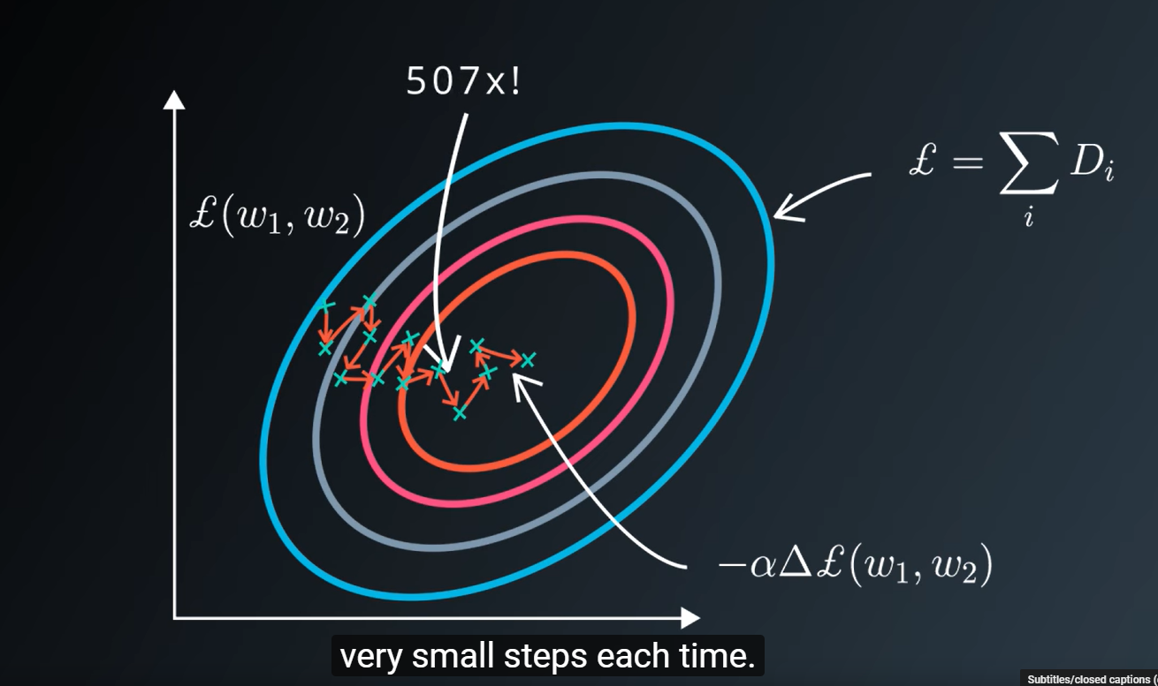

Desi nu este directia corecta, in timp poate sa creasca acel loss, nu sa il reduca. Dar vom compensa treaba asta, prin a calcula de foarte multe ori, prin pasi foarte foarte mici.

Deci, fiecare step, este mult mai ieftin sa il calculam, dar platim cu timpul. Dar in balance, castigam mult mai mult

ASTA SE NUMESTE **STOCHASTIC GRADIENT DESCENT**

**Momentum and Learning Rate Decay**

**Link:** <https://www.youtube.com/watch?v=O3QYdmQjXds>

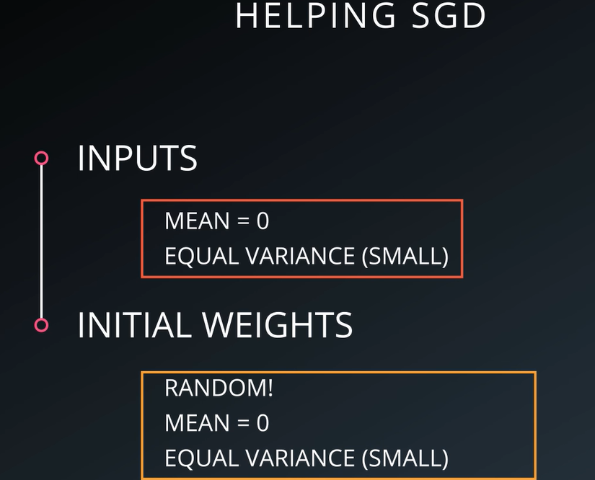

**Deci,** pana acum am discutat ca inputurile sa le luam cu Mean = 0, si cu variante egale. Apoi weight-urile sa le luam randomizate. Acum o sa discutam de inca cateva trucuri ce le putem folosi sa implementam Stochastig Gradient Descent (SGD)

1. **Momentum**

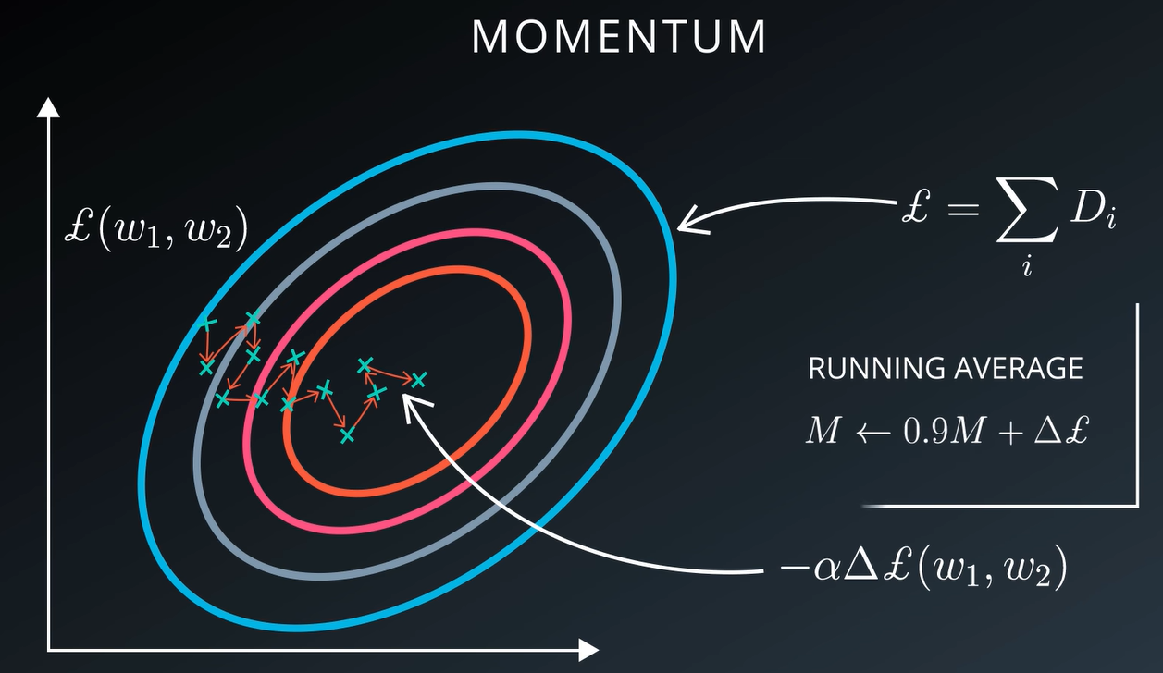

Deci pana acum am vazut ca folosim pasi mici, batch-uri de date, calcula lossul apoi derivata care sa ne indice incotro sa ne indreptam.

Dar, acum am vrea sa invatam mereu si din pasii anteriori.

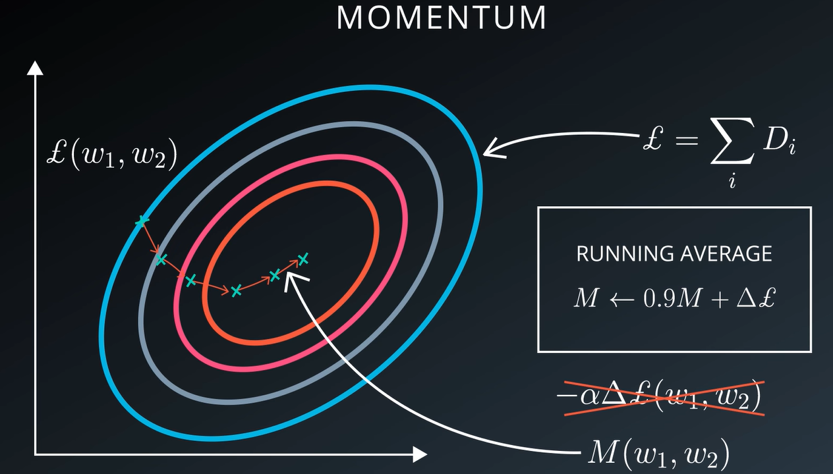

O metoda simpla si ieftina, este sa pastram in memorie mereu, o medie ale acestor gradient ale lossului si sa folosim acea medie, in locul directiei date de batchul current de date

This momentum technique works very well and often leads to better convergence.

1. **Learning Rate Decay**

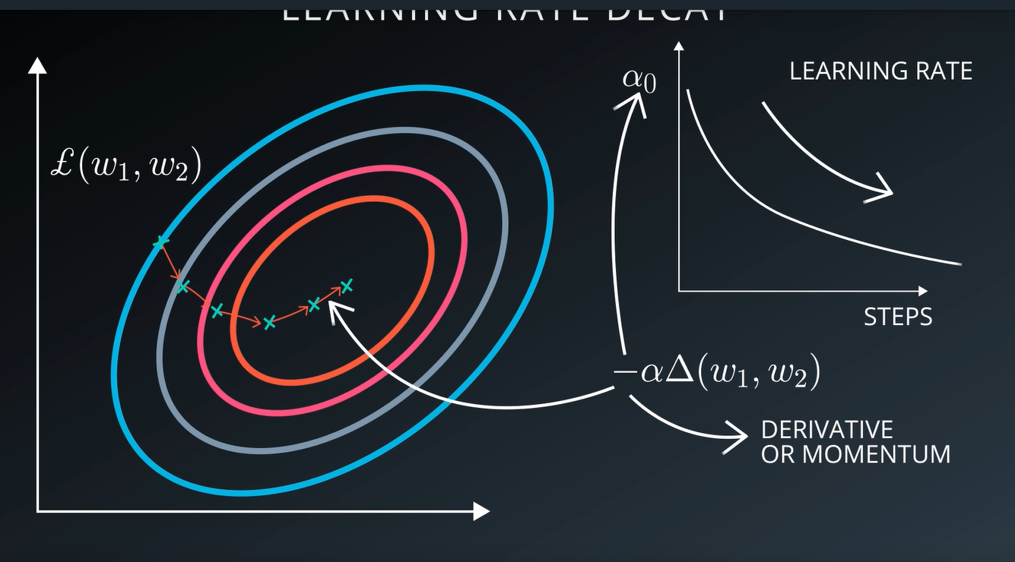

Remember, when we replaced Gradient Descent with SGD(Stochastic GD), We said that we were going to take smaller noisier steps towards our objective.

**How small should that step be? =>** This is a whole area of research as well.

One thing that’s always the case, however is that, it’s beneficial to make that step smaller and smaller as you train.

Some like to apply an exponential decay to their learning rate.

Some like to make it smaller every time the loss reaches a plateau.

There are a lots of ways, but lowering it overtime is the key thing to remember.

**Parameter Hyperspace**

Link: <https://www.youtube.com/watch?v=5a3-iIhdguc>

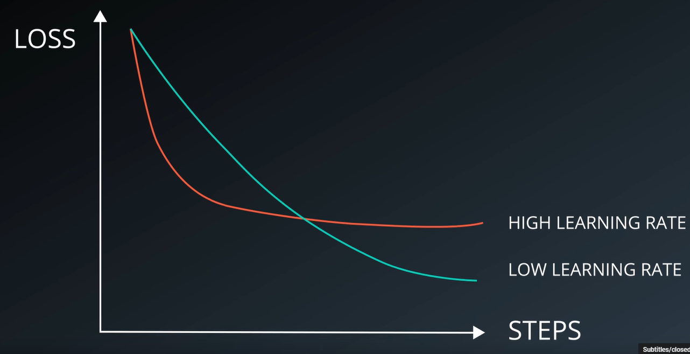

* Idea de baza este sa folosim un Learning rate nici prea mare, dar nici prea mic.
* Ca sa alegi asta e bine sa plotuiesti acea curba realizata de LOSS, STEPS

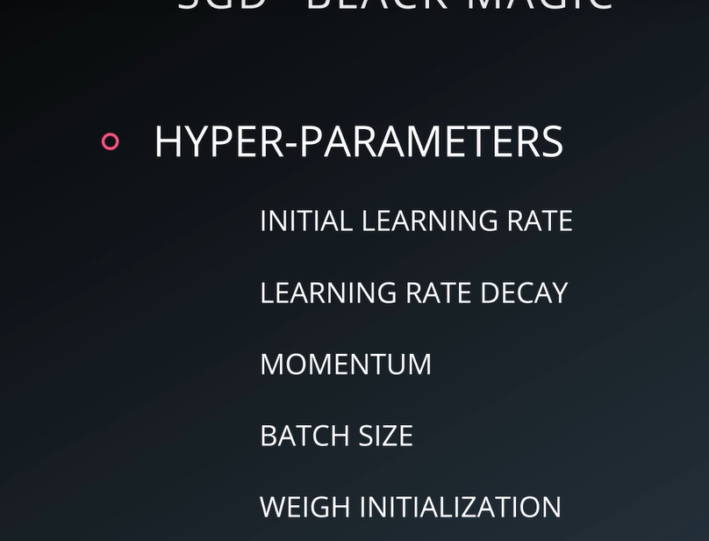

De aici SGD isi are reputatia, ca are foarte multi parametrii cu care te poti juca.

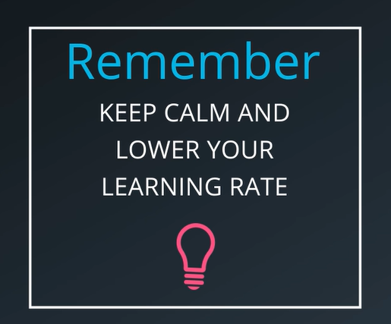

Dar daca ar fii sa retii doar un singur lucru, DACA lucrurile nu merg: **KEEP CALM AND LOWER YOUR LEARNING RATE**

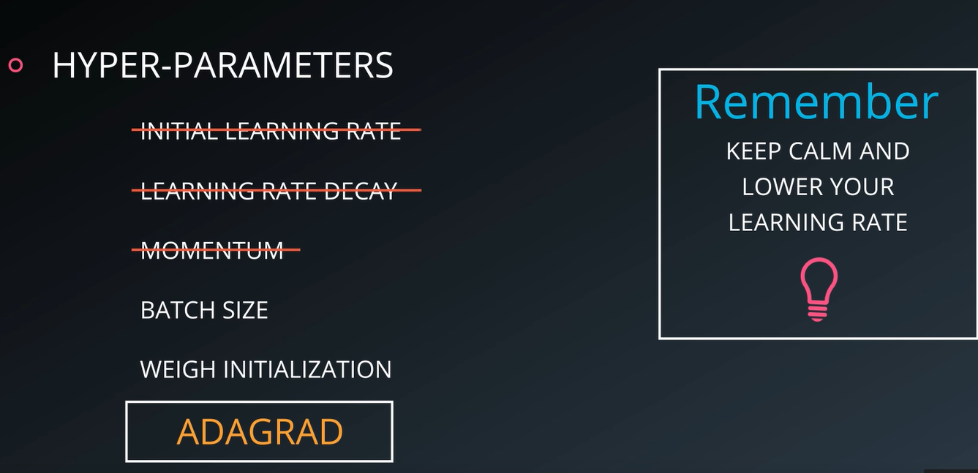

Un alt approach se numeste **ADAGRAD =** that makes things a little bit easier. Is a modification of SGD which implicitly does momentum and learning rate decay for you.

**Mini - batch**

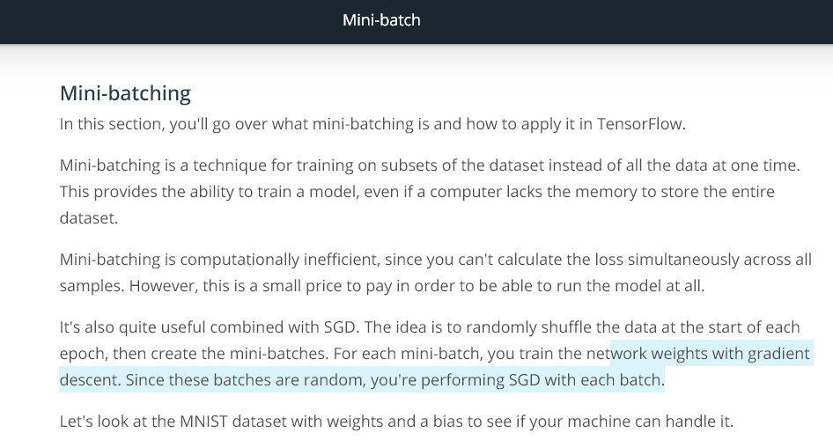

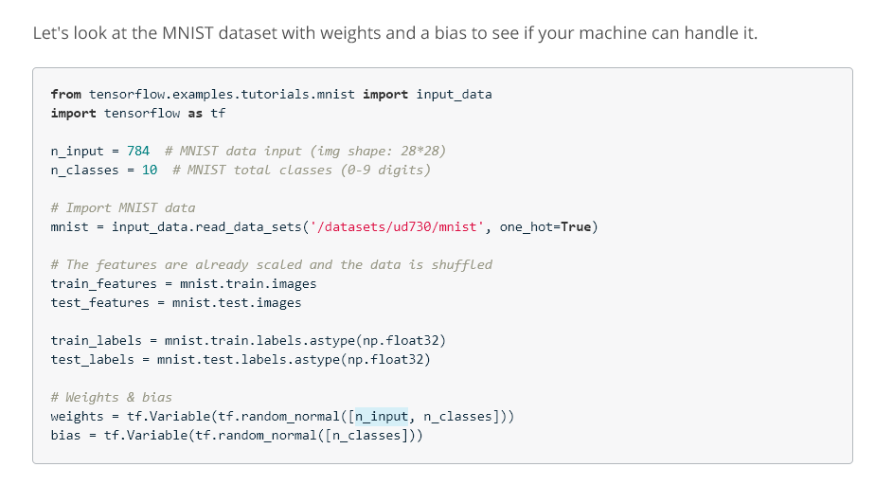

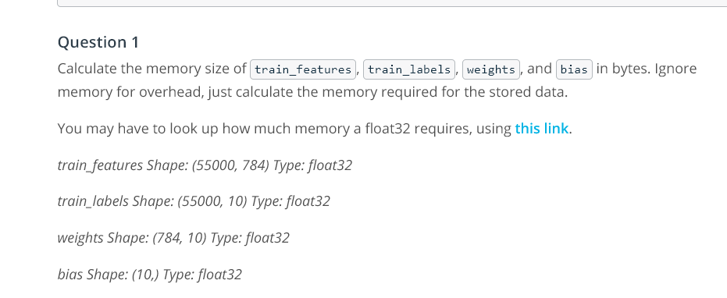

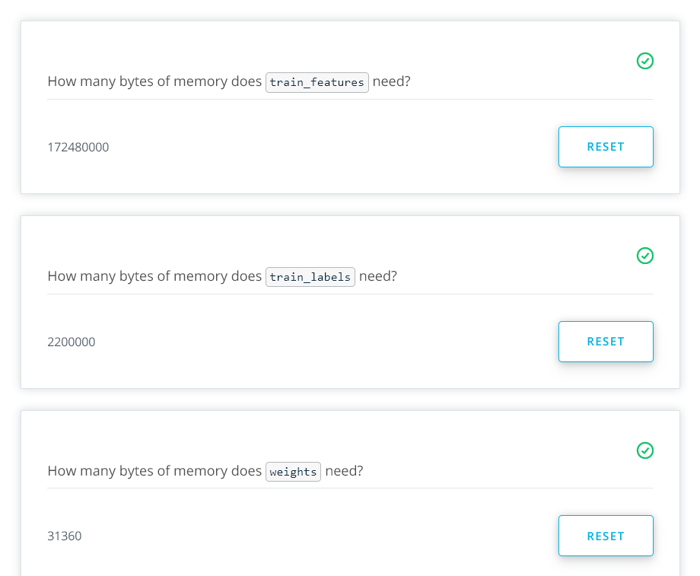  
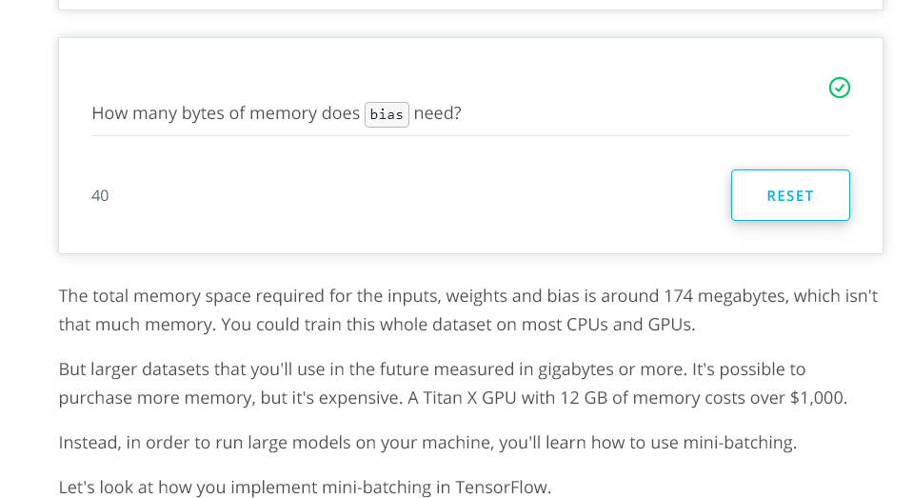

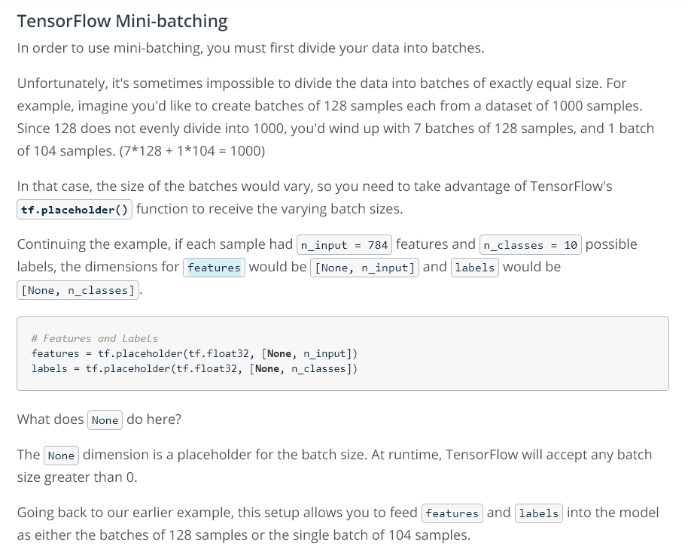

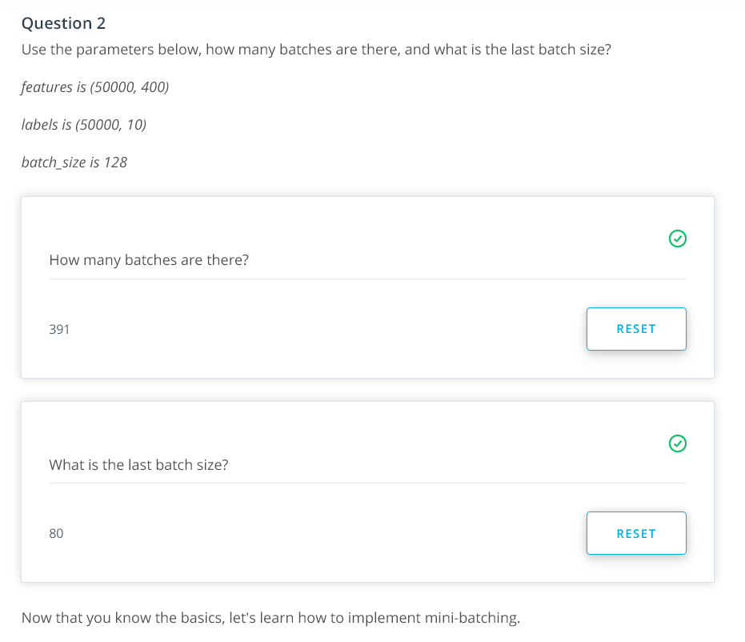

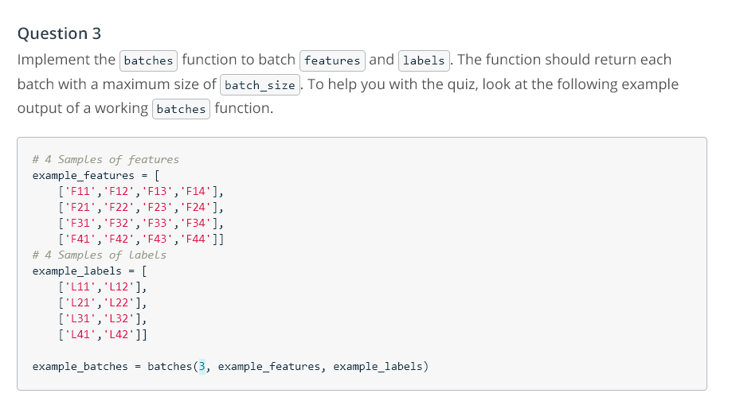

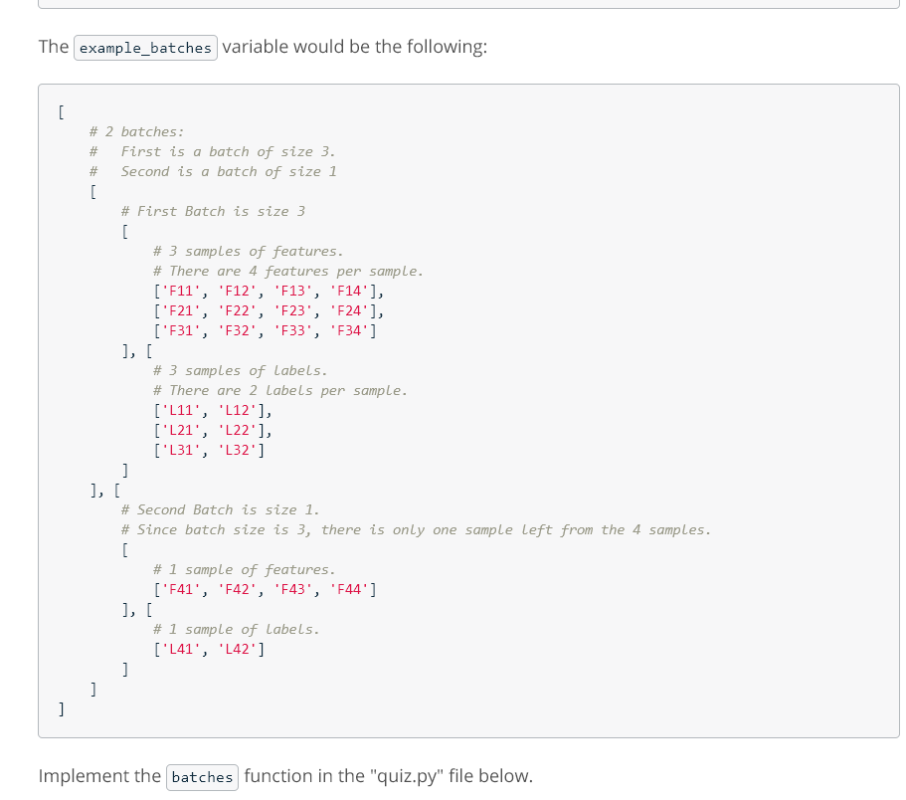

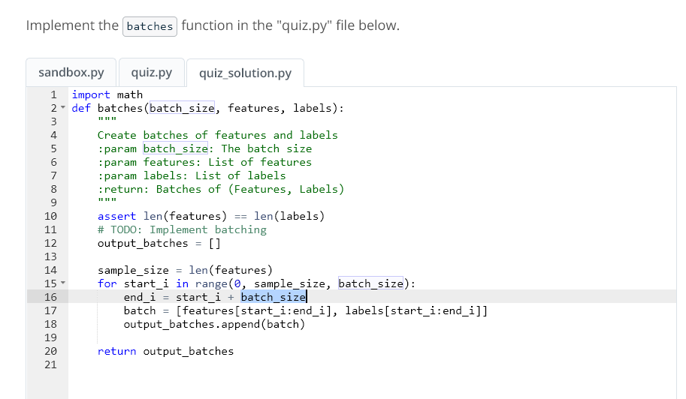

**Quiz 2: Mini-batch**

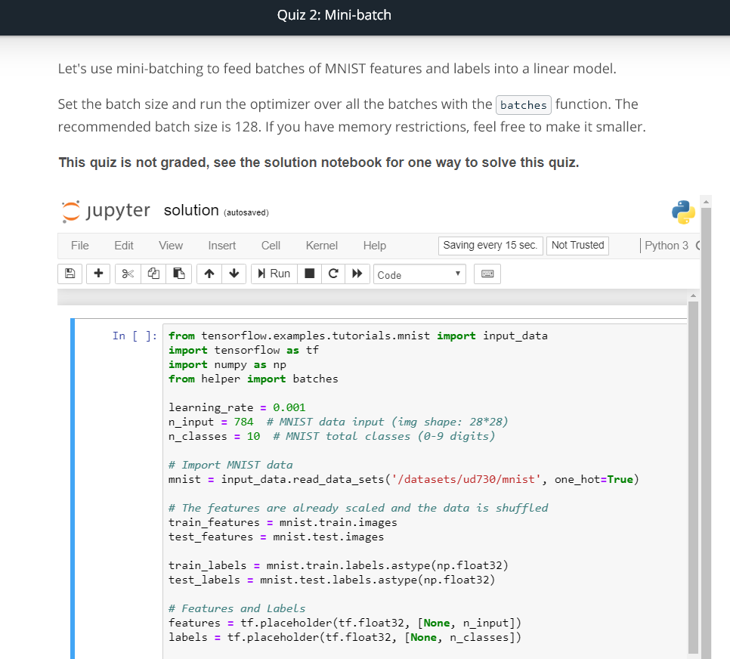

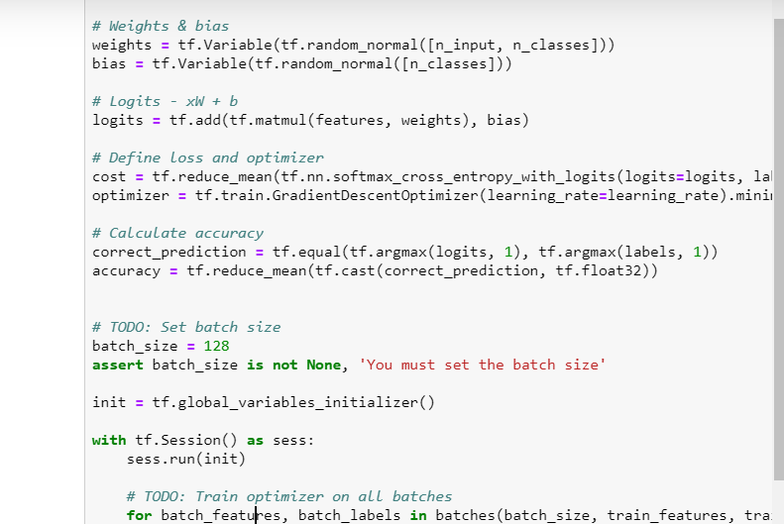

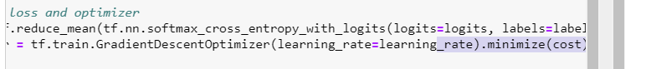

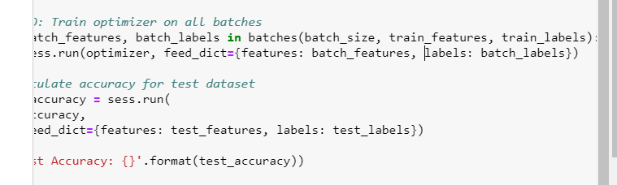

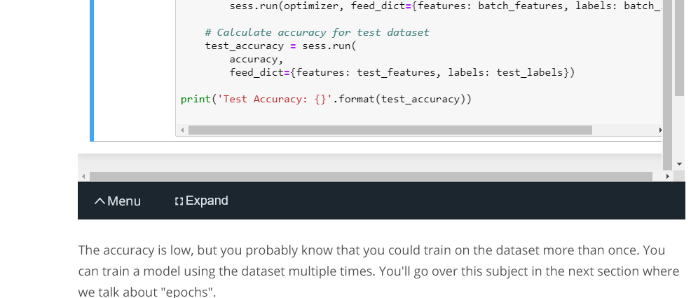

**Epochs**

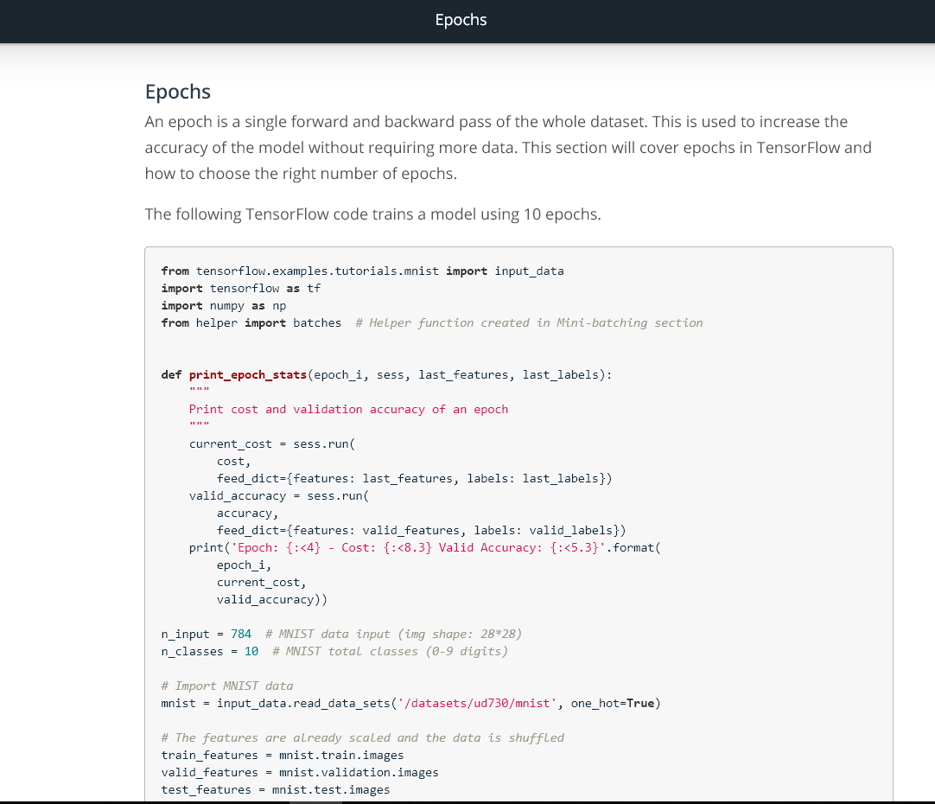

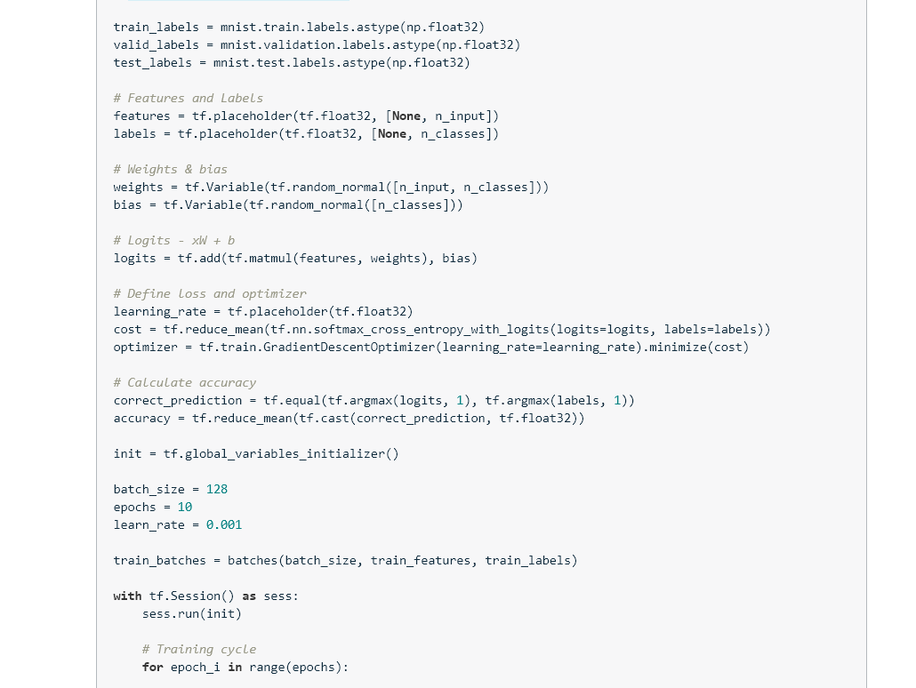

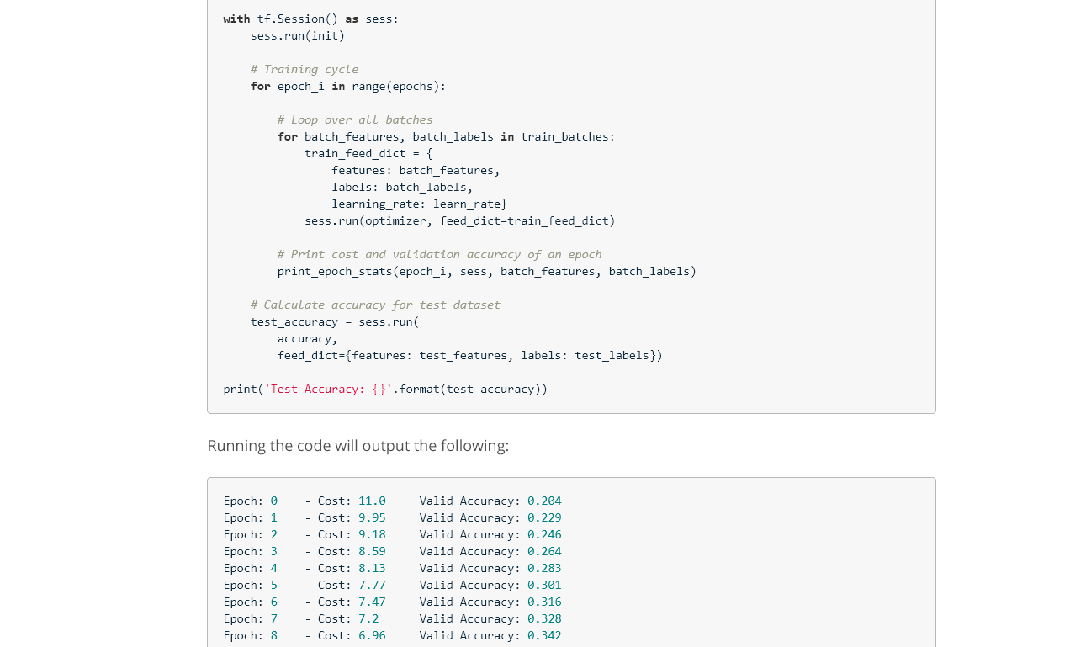

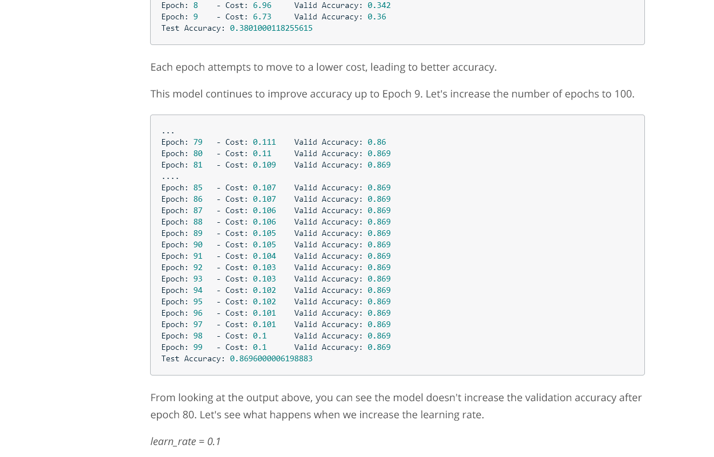

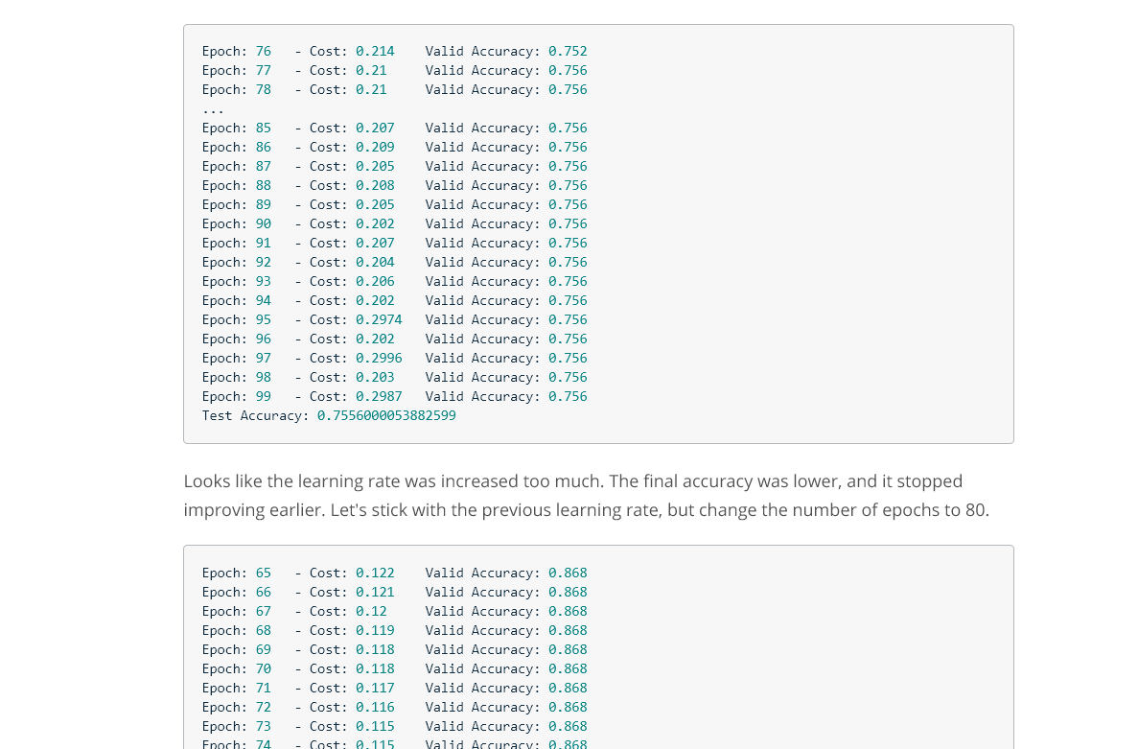

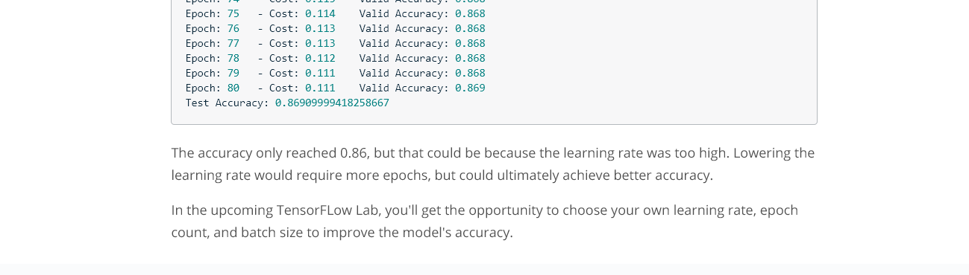

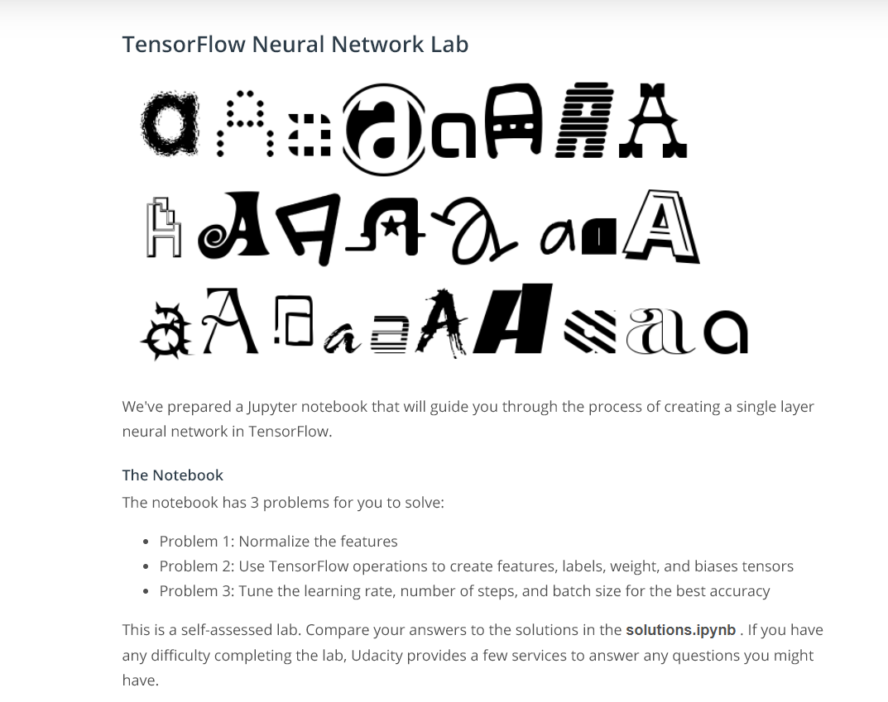

Lab:



